HHS CMS HR BizFlow System

Operations and Maintenance Guide

Document Control Information

Document Information

|  |  |
| --- | --- |
| Document Identification | HHS CMS BizFlow HR Operations and Maintenance Guide.docx |
| Document Name | Operations and Maintenance Guide |
| Project Name | HHS CMS BizFlow HR System |
| Client | Centers for Medicare and Medicaid |
| Document Author | Steven Yang |
| Document Version | 1.0.0 |
| Document Status | Draft |
| Date Released | 28-Jul-2017 |
| Business Specifications Requirement Document ID |  |
| Functional Specification ID |  |

Document Edit History

| Version | Date | Additions/Modifications | Prepared/Revised by |
| --- | --- | --- | --- |
| 1.0 | 07/28/2017 | Initial draft. | Steven Yang |
| 1.1 | 02/08/2018 | Added DB password change instruction | Steven Yang |

Document Review/Approval History

| Date | Name | Organization/Title | Comments |
| --- | --- | --- | --- |
|  |  |  |  |
|  |  |  |  |
|  |  |  |  |
|  |  |  |  |
|  |  |  |  |

Distribution of Final Document

The following people are designated recipients of the final version of this document:

| Name | Organization/Title |
| --- | --- |
| <Name> | <Organization/Title> |
|  |  |

Table of contents

1 Introduction 4

2 Required Software Development Tool Information 5

3 Development Directory Structure 6

3.1 Database Module 6

3.1.1 Database objects in HHS_CMS_HR schema 6

3.1.2 Database objects in BIZFLOW schema 8

3.2 Java Module 9

3.2.1 Prerequisite 9

3.2.2 Source code and required files 9

3.2.3 Module Build 9

3.2.4 Module Deployment 9

3.2.5 Log files 10

3.2.6 Configuration files 10

3.3 Process Module 11

3.4 UI Module 18

3.4.1 Deployment of individual project from WebMaker Studio 19

4 Deployment file storage 22

4.1 Navigation to development file location in Confluence 22

5 Database Password Change 23

5.1 BIZFLOW Schema 23

5.1.1 BizFlow Server Database Connection (login.dat) 23

5.1.2 BizFlow WebMaker BIZFLOW Database Connection 24

5.1.3 BizFlow Advanced Reporting (BAR) BIZFLOW Database Connection 24

5.1.4 BizFlow Advanced Reporting (BAR) BIZFLOWREPORT Database Connection 24

6 BizFlow Update Installer 26

6.1 Installing BizFlow Update Installer in an AIX, HP-UX, Linux, or Solaris Environment 28

6.1.1 Downloading BizFlow Update Installer 28

6.1.2 Installing BizFlow Update Installer 29

6.1.3 Starting the BizFlow Update Installer Server 29

6.1.4 Stopping the BizFlow Update Installer Server 30

6.1.5 Starting the BizFlow Update Installer Client 30

6.2 Updating BizFlow Update Installer 30

6.2.1 Automatic Update 30

6.2.2 Manual Update 32

6.2.3 Offline Update 33

6.3 Using the BizFlow Update Installer 33

6.3.1 Setting Your BizFlow Update Installer Password 34

6.3.2 Welcome Page Overview 34

6.3.3 Changing Settings 35

6.3.4 Installing Updates 42

6.4 Uninstalling Installed Updates 48

6.5 Viewing Update History 52

6.6 Exiting BizFlow Update Installer 54

# Introduction

This document describes the modules of the HHS CMS BizFlow HR system: how they are structured and how they may be maintained. HHS CMS BizFlow HR system is developed based on BizFlow Development Suite which consists of the following modules: BPM, Web Application, Java, and Database. To maintain the system, a familiarity with BizFlow development process and its software development tools is required.

# Required Software Development Tool Information

1. BizFlow Process Studio version 12.4
2. BizFlow WebMaker Studio version 12.4
3. Database client for Oracle 12c
4. Java: JDK 7 or 8
5. Text editor and/or Java IDE

A developer must be proficient in the following software development tools.

* BizFlow Process Studio (BPS): The Business Process Management (BPM) development tool for BizFlow.
* WebMaker Studio: Web Application UI development tool for forms associated with BizFlow Process Definition.
* Jave Development Kit (JDK) and Java Integrated Development Environment (IDE): Java programming tool.
* Oracle SQL+ or SQL Developer: Oracle database development tool.

For BPS and WebMaker, BizFlow Community portal has vast information and documentation. The sign-up is free at <https://community.bizflow.com>.

For BizFlow BPM tutorial,

<https://community.bizflow.com/docs/DOC-2922>

For WebMaker tutorial,

<https://community.bizflow.com/docs/DOC-2767>

If you need BPM and WebMaker training, contact BizFlow Customer Service.

[http://www.bizflow.com](http://www.bizflow.com/)

For JDK and Oracle Database, search “Java Tutorial”, “Oracle Database Documentation” for documentations Oracle home site.

<https://www.oracle.com/index.html>

# Development Directory Structure

The development directory structure is organized by modules that comprise HHS CMS BizFlow HR System, which are Database, Java, Process, and UI.

* /development/database/
* /development/java/
* /development/process/
* /development/ui/wm-project/

## Database Module

The database directory contains database scripts (.sql files) to create database schema, users, and other objects, which includes the definition for tables, stored procedures, functions, triggers, sequence. HHS_CMS_HR schema is created to hold the database objects for HHS CMS BizFlow HR system specific entities. There are also a small number of objects added to BIZFLOW schema. HHS_CMS_HR database user must have proper permission to access BIZFLOW objects.

The developer maintains database objects and reference data through the database the script files, which can be executed by DBA to the target environment other than development environment (i.e. QA, PROD).

Any Oracle database client software can be used to maintain the DB scripts. The prime example of a database client software tools are SQL+ and SQL Developer.

### Database objects in HHS_CMS_HR schema

CMS_HR_DB_01_create_schema.sql

* Defines database, specifying tablespace and database file location.
* Creates database users and schemas.
* Creates database roles.
* Grants permissions to the database users and roles.
* It is a one time job to run this script to establish a new environment from scratch. ***Once an environment is set up, this script should not be run ever again***.

CMS_HR_DB_02_grant_permission_bizflow.sql

* Grants permissions for accessing BizFlow’s core database tables to the designated database user.
* HHS_CMS_HR database user needs to access the tables under BIZFLOW schema to perform data reference within stored procedures and functions.

CMS_HR_DB_03_create_model_objects.sql

* Creates tables for CMS business data storage.
* Creates sequences, constraints, and triggers associated with the tables.
* Creates stored procedures.

CMS_HR_DB_04_grant_permission_model.sql

* Grants permissions for accessing the newly created database objects for business data model in the previous step to the designated database roles.

CMS_HR_DB_05_create_core_table.sql

* Creates tables for generic use by program objects (functions and stored procedures).
* Creates sequences, constraints, and triggers associated with the tables.

CMS_HR_DB_06_create_core_program.sql

* Creates stored procedures.
* Creates functions.

CMS_HR_DB_07_grant_permission_core.sql

* Grants permissions for accessing the newly created database objects for program to the designated database roles.

The following scripts insert the initial data to the reference tables.

CMS_HR_DB_08_1_insert_seed_data_LOOKUP.sql

* Inserts the initial lookup data into TBL_LOOKUP table, which will be used as part of numerous dropdown fields.

CMS_HR_DB_08_2_insert_seed_data_REQUEST.sql

* Inserts the data into REQUEST_CONTROL table to be used as seed data for generating Request Number.

CMS_HR_DB_08_3_insert_seed_data_GRADE.sql

* Inserts the data into GRADE_DETAIL table to be used as reference data for Grade field.

CMS_HR_DB_08_4_insert_seed_data_ADMIN.sql

* Inserts the data into ADMIN_CODES table to be used as reference data for Admin Code field.

CMS_HR_DB_08_5_insert_seed_data_LOC_1.sql

CMS_HR_DB_08_6_insert_seed_data_LOC_2.sql

CMS_HR_DB_08_7_insert_seed_data_LOC_3.sql

CMS_HR_DB_08_8_insert_seed_data_LOC_4.sql

CMS_HR_DB_08_9_insert_seed_data_LOC_5.sql

* Inserts the data into LOCATION table to be used as reference data for Location field. The number of records for this table is so large that it is broken into multiple files.

CMS_HR_DB_08_report_objects.sql

* Creates functions used for report views.
* Creates views for business data from HHS_CMS_HR schema.

CMS_HR_DB_09_grant_permission_report.sql

* Grants permissions for accessing the newly created database objects for a report to the designated database roles.

### Database objects in BIZFLOW schema

CMS_BIZFLOW_DB_01_create_objects.sql

* Creates functions used in BizCove.

CMS_BIZFLOW_DB_02_report_objects.sql

* Creates report lookup table and insert reference data.
* Creates functions.
* Creates views for process data from BIZFLOW schema.

## Java Module

Custom Java module was developed to provide PDF document generation functionality.

### Prerequisite

Following softwares are required to build PDF generation module.

* JDK 1.7 or higher (Use the same version of JDK which BizFlow Server is using. Refer 2. Required Software Development Tool Information.
* Apache Ant 1.9.7 or higher

### Source code and required files

Java source code for PDF generation (cmspdf.zip) is located under [Confluence]/Development Repository/Jar folder.

The following directories and files can be found from root level directories after extracting cmspdf.zip file.

/lib -- Library directory

/PDF_Configuration -- Configuration file for PDF Generation

/src -- Source code directory

cmspdf.properties -- ANT property file

cmspdf.xml -- ANT build configuration

module_cmspdf.xml -- ANT property file

/resources -- Empty directory. Required for ANT build

### Module Build

Execute following command from root directory of the extracted cmspdf.zip file.

ant –buildfile cmspdf.xml

Ant will create cmspdf.jar file under [Extracted cmspdf.zip directory]/out/artifacts/lib.

### Module Deployment

PDF Generation module should be deployed to Tomcat for WebMaker.

Deployment steps are

* Shutdown Tomcat.
* Copy /lib directory contents from extracted cmspdf.zip file to [*Tomcat*]/webapps/bizflowwebmaker/WEB-INF/lib directory.
* cmspdf.zip file contains cmspdf.jar file in /lib directory. If you build cmspdf.jar, then copy latest cmspdf.jar file to [*Tomcat*]/webapps/bizflowwebmaker/WEB-INF/lib directory.
* Copy /PDF_Configuration/HWSessionFactory.properties file to [*Tomcat*]/webapps/bizflowwebmaker/WEB-INF/classes directory.
* Copy /PDF_Configuration/log4j.properties file to [*Tomcat*]/webapps/bizflowwebmaker/WEB-INF/classes directory.
* Copy /PDF_Configuration directory and its contents to [*Tomcat*]/webapps/bizflowwebmaker/WEB-INF directory.
* Start up Tomcat.

### Log files

As a default, log file (cmspdf.log) will be created under [Tomcat]/logs directory. You can adjust log file location by changing log4j.properties file. If log4j.properties file is modified, make sure restart Tomcat.

### Configuration files

PDF Generation module is using three kinds of configuration files.

* Template – Template PDF file, which has a layout. PDF Generation module will put a real value to this empty PDF template file.
  + Template files are located under [*Tomcat*]/webapps/bizflowwebmaker/WEB-INF/PDF_Configuration/template directory.
* Map – Map property file contains keyword which is used by layout property and value which will be retrieved from BizFlow or database.
  + Map files are located under [*Tomcat*]/webapps/bizflowwebmaker/WEB-INF/PDF_Configuration/map directory.
  + Map property file has a naming convention which file name will end with _MAP postfix.
* Layout – Layout property file contains a template name and keywords with a location in template PDF file.
  + Layout files are located under [*Tomcat*]/webapps/bizflowwebmaker/WEB-INF/PDF_Configuration/map directory.
  + Layout and Map property files are paired. If Layout property name is “ABC.xml”, then Map property file name should be “ABC_Map.xml”.

## Process Module

The Process module is captured as a BizFlow Import Export file (.bix files), which contains the process definition, the application definition, user group definition, BizCove and menu design.

The system administrator will use BizFlow Process Studio to import the .bix file to a designated BizFlow Server environment.

CMS_20170630.bix

The BIX file name has “CMS” with date of generation as suffix, and file extension.

Note: the developer must have proper license and Authority Group assigned. To verify the BizFlow user with proper permission, log in to BizFlow Portal site as a system administrator, and check the Authentication configuration.

1. Log in to BizFlow Portal as a system administrator.
2. Click “ADMINISTRATION” tab on the top right corner.
3. Click Authentication on the administration page.
4. Search the user login to verify and click on the login ID found to open User Details wizard.
5. Click License tab and Authority Group tab in the wizard to verify the license assignment and Authority Group assignment.

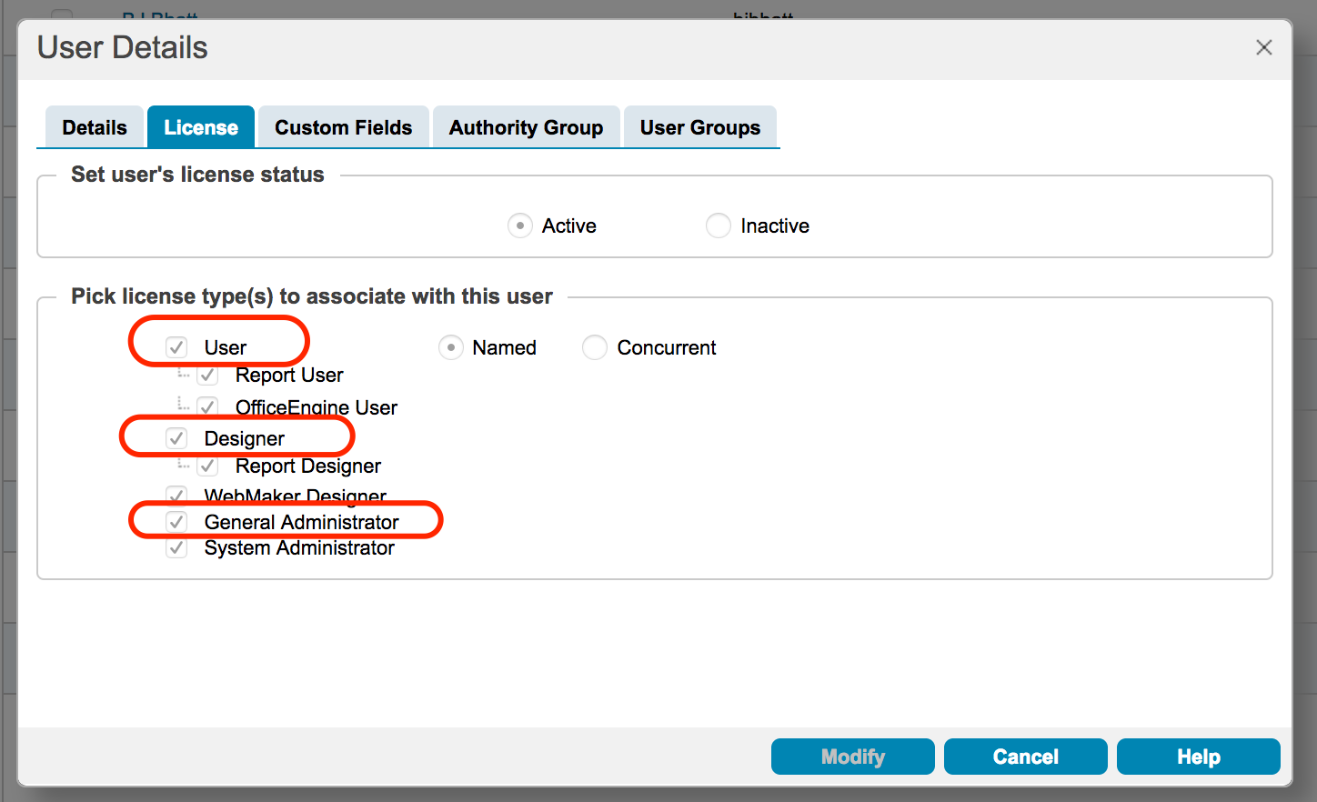

For Authority Group assignment option, it is recommended to use “Explicit.” Then, make sure explicitly select Designer and General Administrator Authority Group along with others.

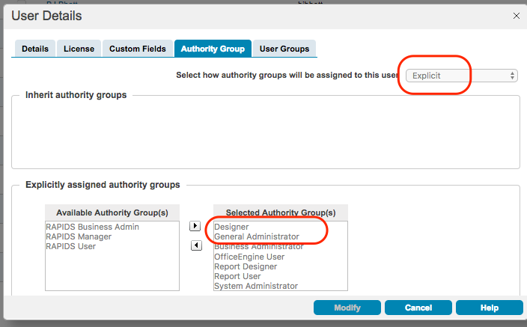

The developer maintains the process definition and application definition using BPS.

1. Laungh BPS
2. If the development environment icon is not established in the BizFlow Explorer pane, create one.
   1. Click on the BizFlow Server icon. (or through menu: File > New > BizFlow Server)

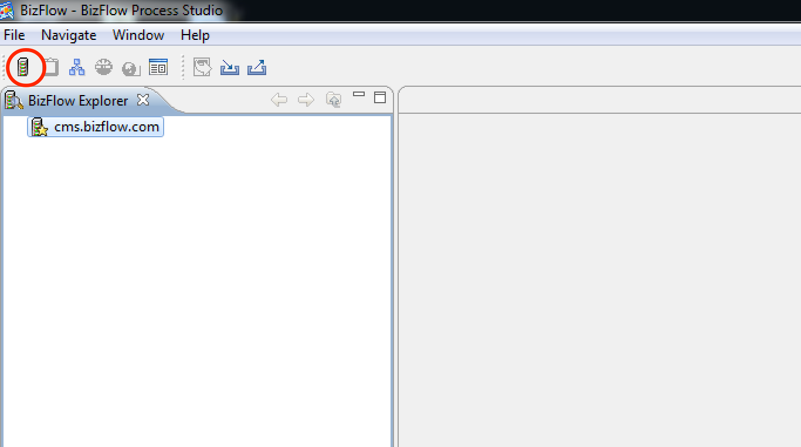

* 1. In the New BizFlow Server dialog, fill in the BizFlow connection information fields, and click OK button.

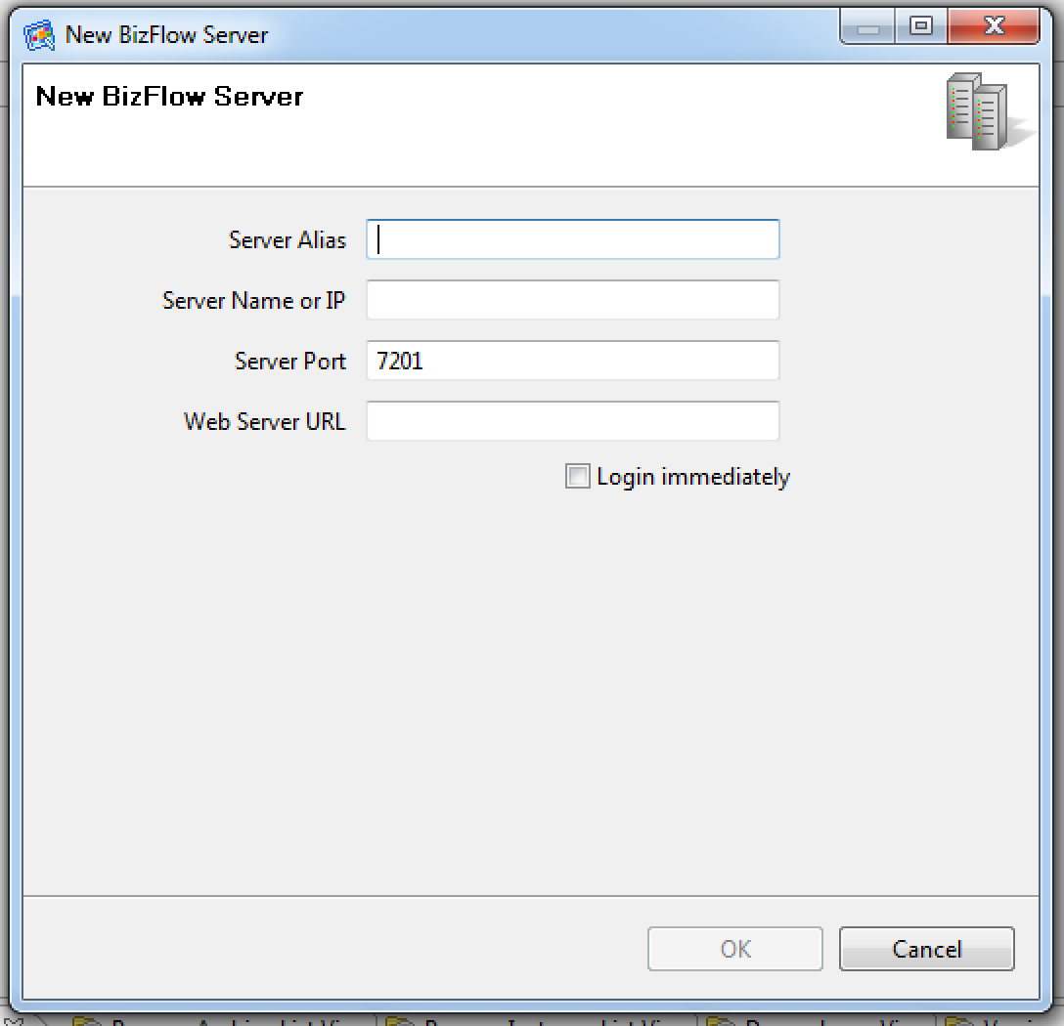

* **Server Alias**: Name that appears in BizFlow Explorer pain. For example: DEV
* **Server Name or IP**: Name or IP address of the server machine that hosts BizFlow Server.
* **Server Port**: BizFlow Server Port for development environment. For example: 7201
* **Web Server URL**: BizFlow Web Portal URL. For example: https://dev.cms.bizflow.com/bizflow

***Note***: The actual connection information value may change in the future. Contact system administrator for details.

1. From the BizFlow Explorer pane, double click on the development environment.
2. In the Login dialog, enter login information, and click OK button.

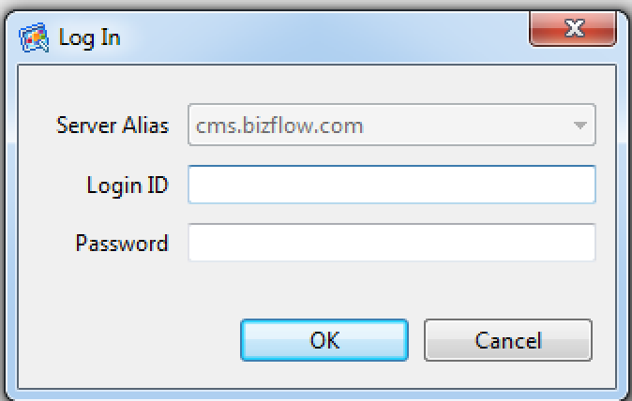

1. If a development project folder is not established, create one.
   1. Select the DEV environment on the BizFlow Explorer.
   2. Click on the Project icon. (or through menu: File > New > Project)

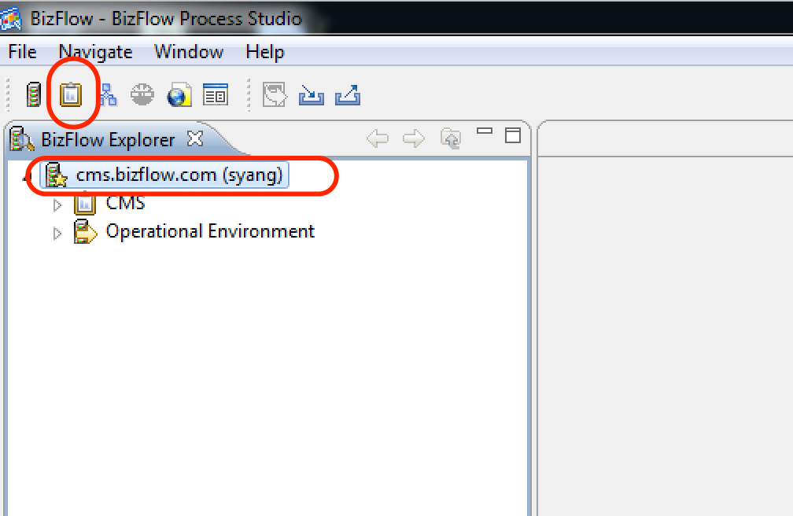

* 1. For Project Name, enter “CMS”, and click Finish button.

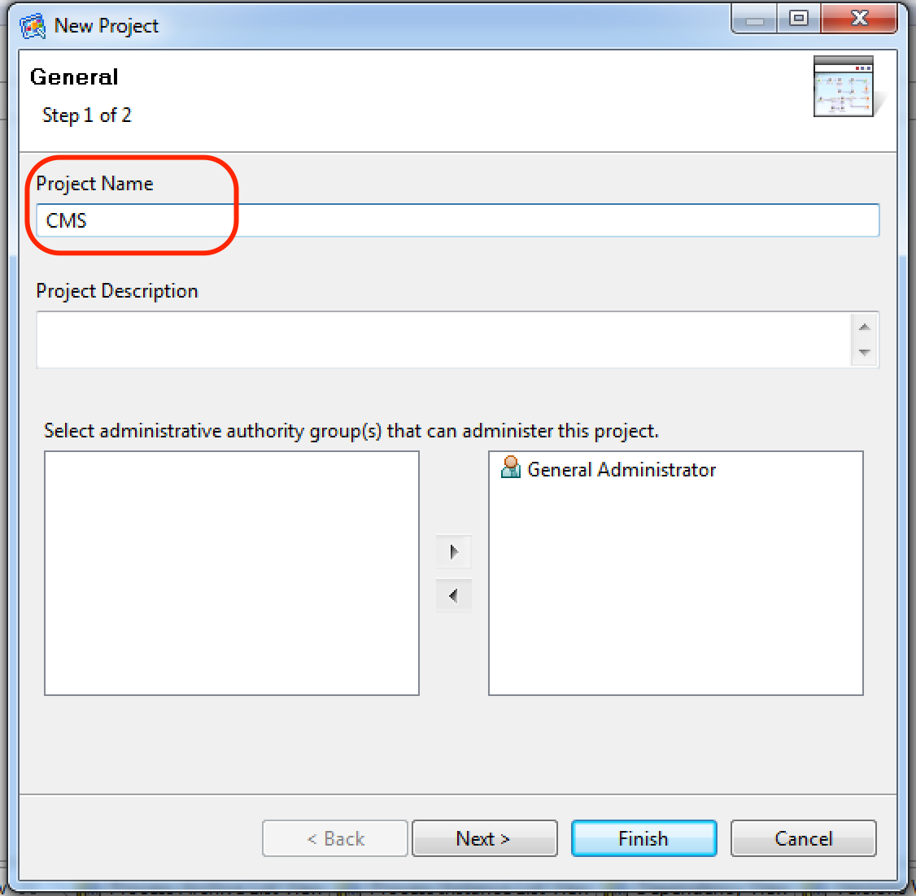

1. Expand the development environment on BizFlow Explorer pane and navigate to process definition for maintenance. Double-click items under Process Definitions folder and Application folder to work on them.

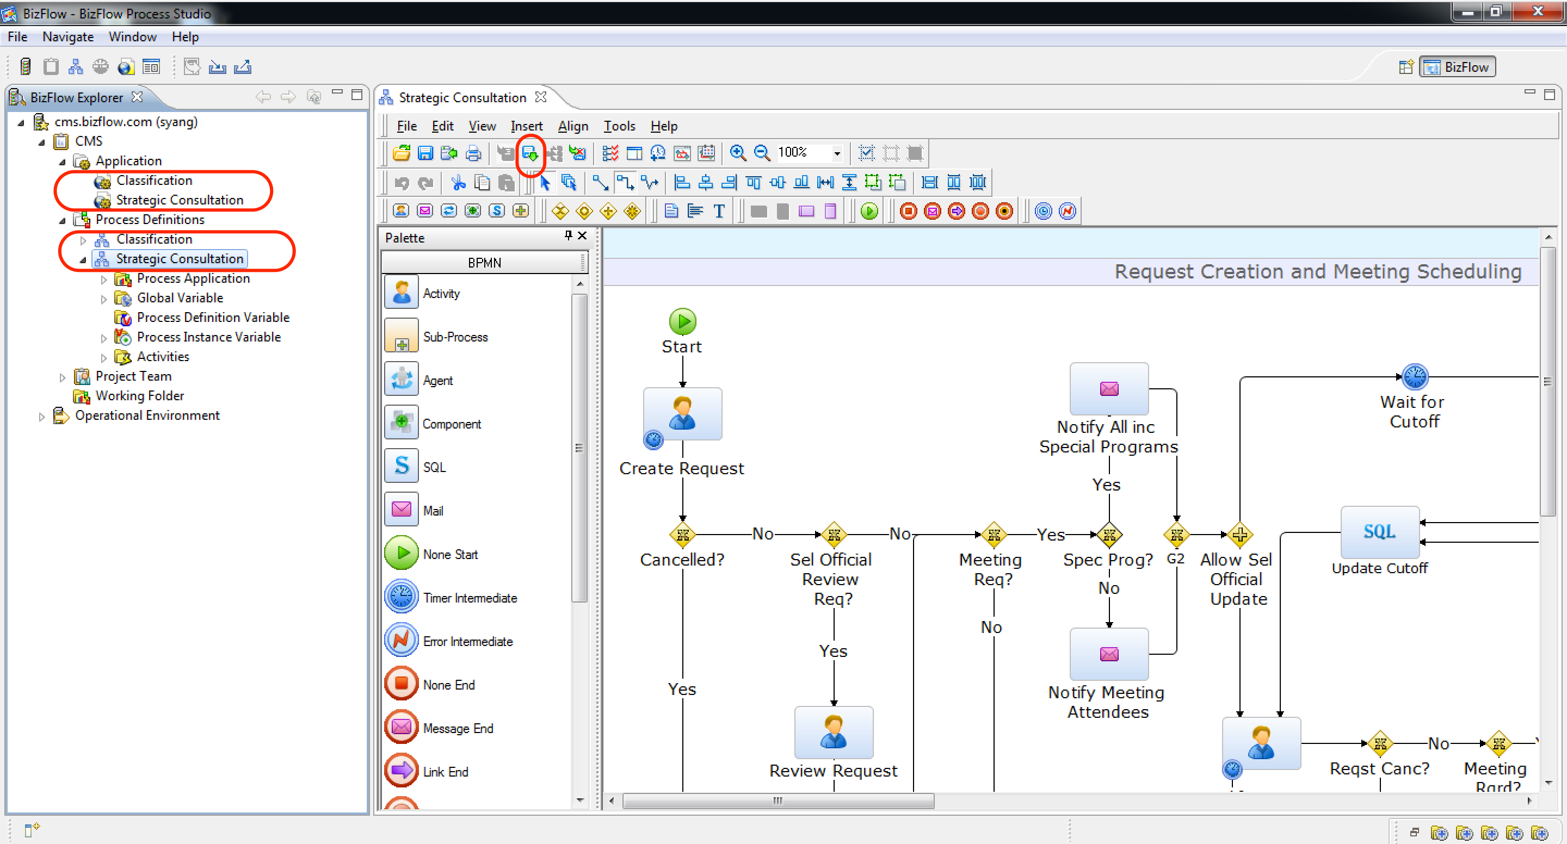

***Note***: When a process definition is open in development project, it is automatically checked out. After you modify process definition, make sure to check-in.

1. After modification is done, publish it to the development BizFlow Server.
2. After publish, perform unit test in development environment.
3. Once ready for release, export BIX to capture Process module.

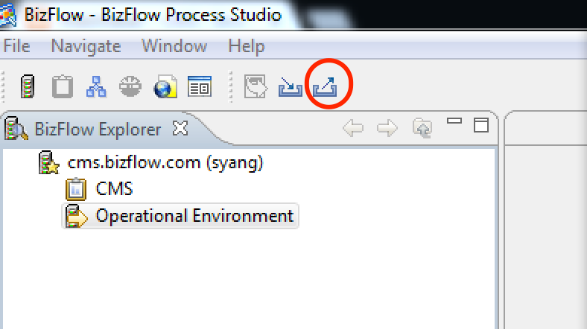

Export file should include the following items.

* User Group > CMS
* Process Definitions > CMS
* Application > CMS
* Component Library > Global Variable
* Menu > NEIL *

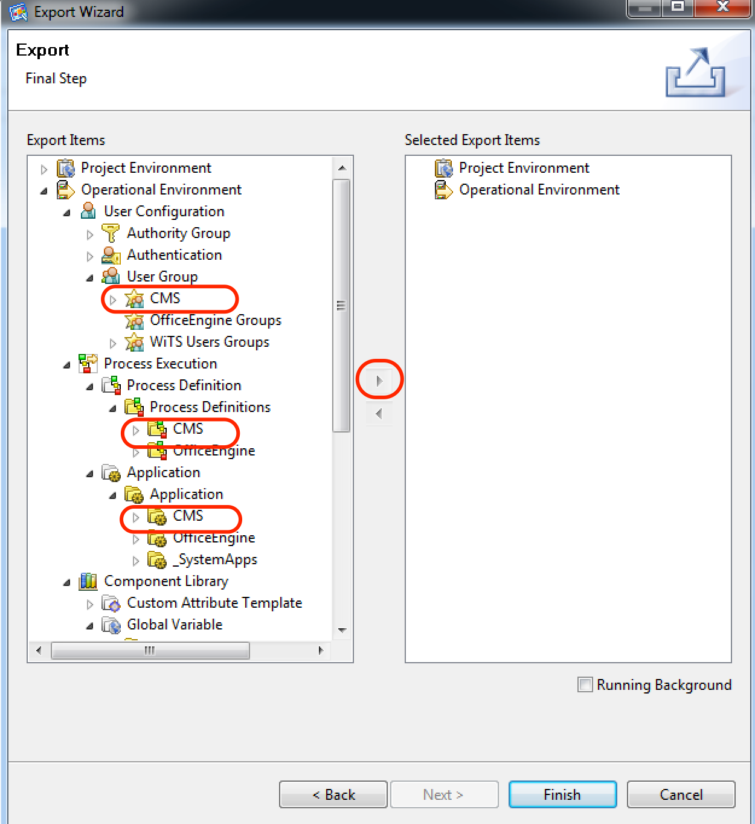

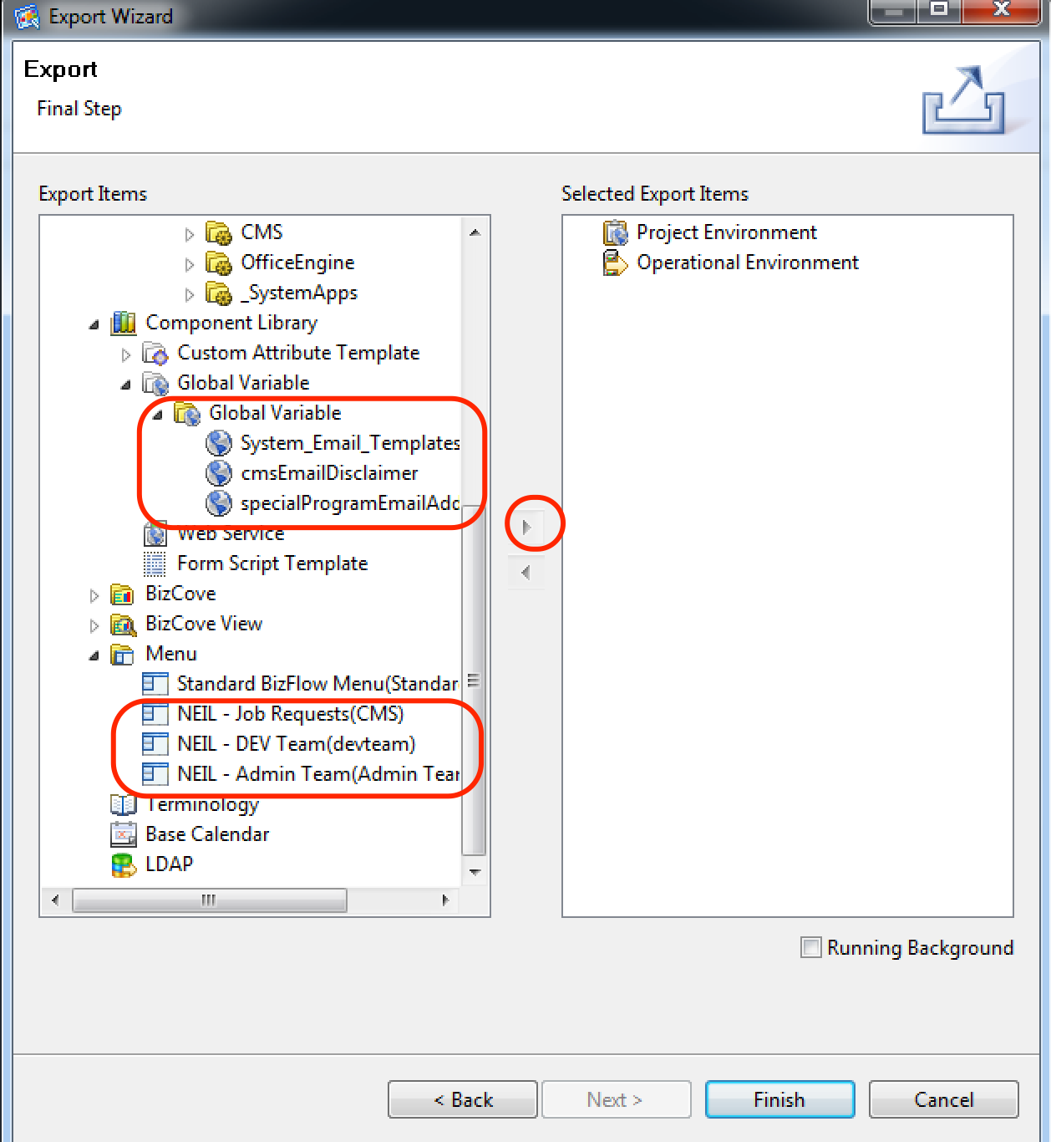

## UI Module

The UI Module (i.e. form) is developed using WebMaker and its artifact is captured in WebMaker project export zip files. To maximize parallel development, each form project is divided into main project and sub-projects for each tab.

Strategic Consultation form projects:

* **StratConMain**: Strategic Consultation form main project. It controls the main frame of the form which has tab structure and action buttons. For each tab, it calls the respective sub-projects to render.
* **StratCon_GEN**: Strategic Consultation form General tab project.
* **StratCon_POS**: Strategic Consultation form Position tab project.
* **StratCon_MTG**: Strategic Consultation form Meeting tab project.
* **StratCon_AOC**: Strategic Consultation form Areas of Consideration tab project.
* **StratCon_smeja**: Strategic Consultation form SME/Job Analysis tab project.
* **StratCon_RI**: Strategic Consultation form Incentives (Recruitment Incentive) tab project.
* **StratCon_TR**: Strategic Consultation form Outreach (Target Recruitment) tab project.
* **StratCon_apr**: Strategic Consultation form Approvals tab project.

Classification form projects:

* **classification_main**: Classification form main project. It controls the main frame of the form which has tab structure and action buttons. For each tab, it calls the respective sub-projects to render.
* **classification_gen**: Classification form General tab project.
* **classification_code**: Classification form Codes tab project.
* **classification_flsa**: Classification form FLSA Exempt/Non-exempt tab project.
* **classification_apr**: Classification form Approval tab project.

**cmscommon**: CMS Common utility project. It contains common images and JavaScript functions that are commonly used throughout CMS UI projects.

**StratCon_AUT**: Auto Complete Search utility project. Even though the project name implies Strategic Consultation form, the API in this project is called from Classification form as well as Strategic Consultation form.

After any change is made to the WebMaker projects, the project should be exported into zip format from WebMaker Studio, and uploaded to the source project directory, i.e. /development/ui/wm-project directory.

StratConMain_export.zip

StratCon_GEN_export.zip

StratCon_POS_export.zip

StratCon_MTG_export.zip

StratCon_AOC_export.zip

StratCon_smeja_export.zip

StratCon_RI_export.zip

StratCon_TR_export.zip

StratCon_apr_export.zip

classification_main_export.zip

classification_gen_export.zip

classification_code_export.zip

classification_flsa_export.zip

classification_apr_export.zip

cmscommon_export.zip

StratCon_AUT_export.zip

, or capture the runtime directories from Development environment’s Tomcat directory (i.e., [Tomcat]/webapps/bizflowwebmaker/[WebMaker project name directories]) and copy to the target environment’s Tomcat webapps directory.

### Deployment of individual project from WebMaker Studio

Where there was any change made to the any of the WebMaker project, the generated UI code should be deployed to the target environment, using WebMaker’s Publish menu.

1. Click menu Publish > Publish Settings

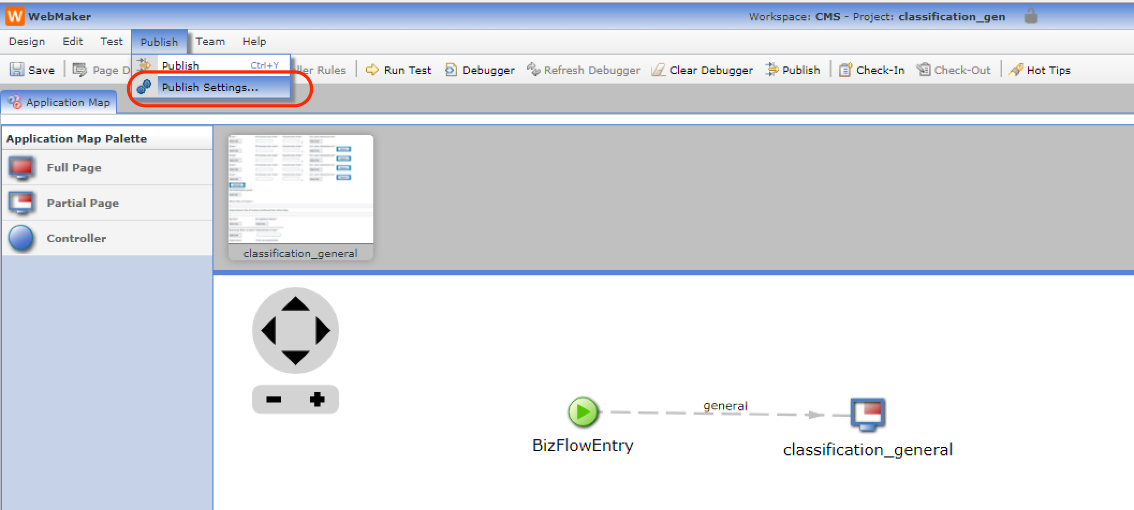

2. Verify the target environment to publish.

2.1. If the target environment is not set up, click “Copy” of one of the existing environment profile in the Publish Settings dialog, and modify to establish the correct environment to publish.

From Local Details section,

* Enter Environment Name, e.g. HHS CMS DEV.
* Enter fallback.server.url, e.g. https://dev.bizflow.hhs.gov/bizflowwebmaker. Note: the server name will be different per environment, e.g. QA = qa.bizflow.hhs.gov, PROD = prod.bizflow.hhs.gov.

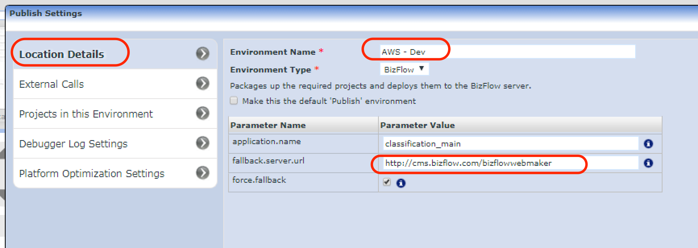

From External Calls section,

* Modify the beinning part of the Location URL for all SOAP Service entries, e.g. https://hrts.dev.hhs.gov/bizflow/webservice/… Make sure scroll down and modify the URL of every entry.

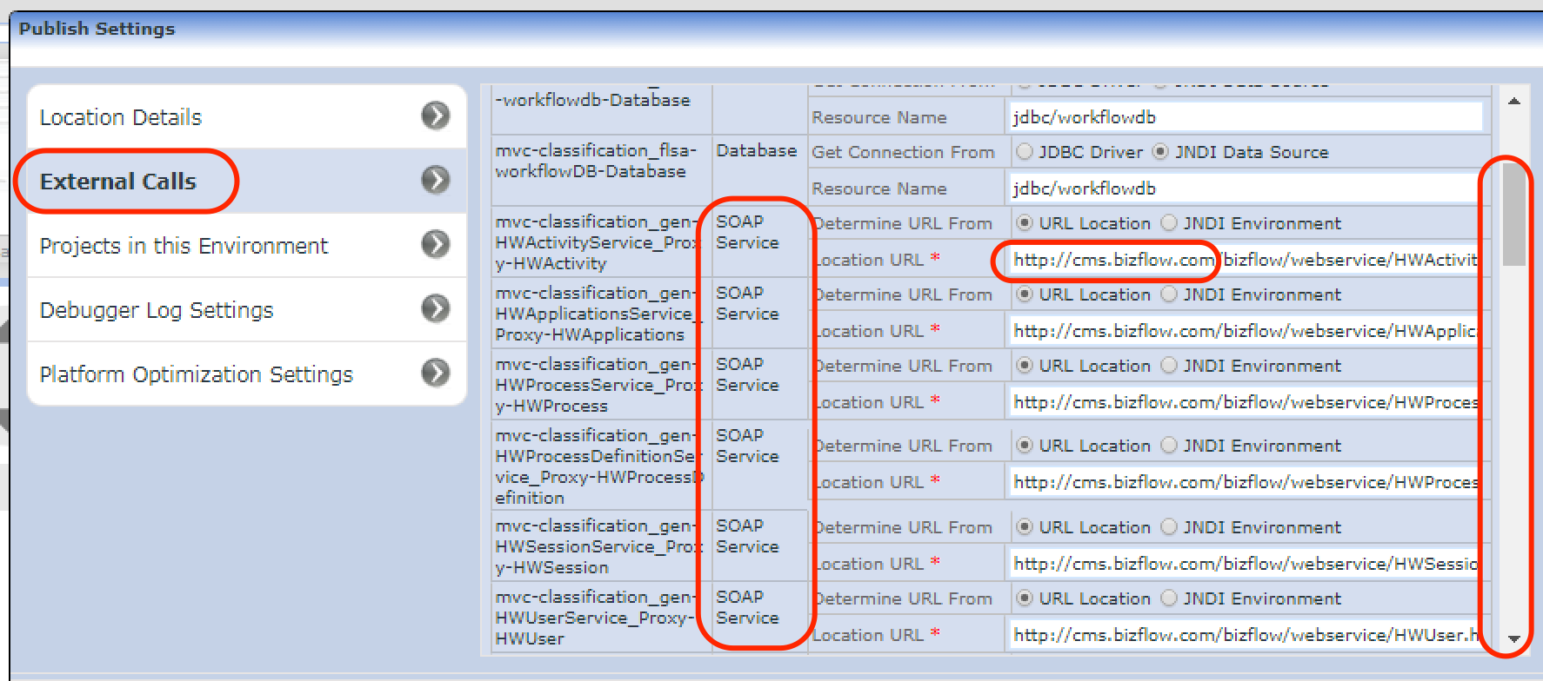

3. Click “Publish” link of the destination environment.

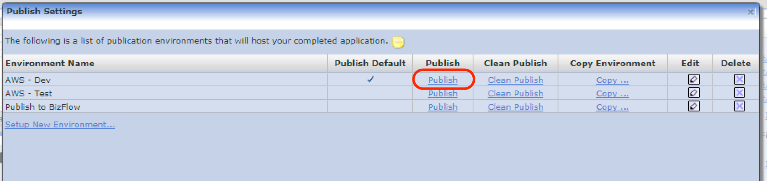

# Deployment file storage

The development files, including source files and runtime files, are uploaded and maintained in the Confluence for HHS CMS BizFlow HR project. (https://hrbizflow.atlassian.net/wiki/display/HB)

Note that Confluence is not a proper tool for Source Code Management (SCM). It is a temporary measure. In the future, the code repository may be migrated to a proper SCM tool, such as Git or Subversion.

## Navigation to development file location in Confluence

1. Log in to Confluence for HHS CMS BizFlow HR.
2. On the left-hand-side navigation panel, expand “Development Repository”
3. Click each sub-directory and upload/download files as needed.

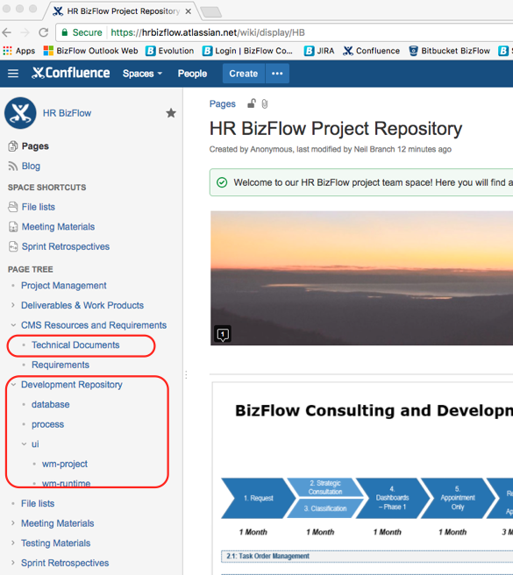

# Database Password Change

When there is database password change, the application configuration needs to be updated accordingly.

## Shutdown BizFlow Server and Web Servers (Tomcat).

## BIZFLOW Schema

### BizFlow Server Database Connection (login.dat)

1. Log in to the target environment server machine as an administrator (or sudo).
2. Change directory to BizFlow Server directory.

For example (assuming the BizFlow Server directory is */apps/bizflow*):

$ cd /apps/bizflow

1. Execute BizFlow environment setup script (bizflowenv.profile).

For example:

$ . /apps/bizflow/bizflowenv.profile

1. Change directory to BizFlow Server bin directory.

For example:

$ cd /apps/bizflow/bin

1. Execute hwsvinst command to verify the execution of it and display its usage.

$ ./hwsvinst

1. Back up existing login data file (login.dat).

For example:

$ cp dat/login.dat dat/login_backup_20180207.dat

1. Execute hwsvinst command to create new database connection information. You need to execute the command twice one without “-n” option and one with “-n” option.

$ ./hwsvinst –u <database_userid> –p <database_user_password> -t <oracle_sid>

$ ./hwsvinst –u <database_userid> –p <database_user_password> -t <oracle_sid> -n bizflowpipe

For example:

$ ./hwsvinst –u BIZFLOW –p <database_password_for_BIZFLOW> -t <oracle_sid>

$ ./hwsvinst –u BIZFLOW –p <database_password_for_BIZFLOW> -t <oracle_sid> -n bizflowpipe

### BizFlow WebMaker BIZFLOW Database Connection

1. Log in to the target environment server machine as an administrator (or sudo).
2. Change directory to Tomcat Configuration (conf) directory.

For example (assuming BAR tomcat directory is */apps/tomcat7*):

$ cd /apps/tomcat7/conf

1. Open a text editor and modify BIZFLOW database connection information in the configuration file (context.xml).

<Resource

name="jdbc/workflowdb"

auth="Container"

type="javax.sql.DataSource"

…

username="bizflow"

password="*<database_password_for_BIZFLOW>*"

…

/>

### BizFlow Advanced Reporting (BAR) BIZFLOW Database Connection

1. Log in to the target environment server machine as an administrator (or sudo).
2. Change directory to BizFlow Advanced Reporting WEB-INF directory.

For example (assuming BAR tomcat directory is */apps/tomcat7*):

$ cd /apps/tomcat7/webapps/bizflowadvreport/WEB-INF

1. Open a text editor and modify BIZFLOW database connection information in the configuration file (applicationContext-bizflow-security.xml).

<property name="bizFlowDBKeychain"><value>*changed_BIZFLOW_database_password*</value></property>

### BizFlow Advanced Reporting (BAR) BIZFLOWREPORT Database Connection

1. Log in to the target environment server machine as an administrator (or sudo).
2. Change directory to BizFlow Advanced Reporting META-INF directory.

For example (assuming BAR tomcat directory is */apps/tomcat7*):

$ cd /apps/tomcat7/webapps/bizflowadvreport/META-INF

1. Open a text editor and modify BIZFLOW database connection information in the configuration file (context.xml).

<Resource

name="jdbc/jasperserver"

auth="Container"

type="javax.sql.DataSource"

…

username="bizflowreport"

password="*<database_password_for_BIZFLOWREPORT>*"

…

/>

### Restart BizFlow Server and Tomcats. Check log files whether database connection is made successfully.

# BizFlow Update Installer

The BizFlow Update Installer is an application to deploy an update or updates on BizFlow server-side components, such as BizFlow Server, BizFlow EJB Service, BizFlow Form Server, BizFlow Script Service, BizFlow ERA, BizFlow Web application (bizflow, bizflowform, era), BizFlow Documentum Adapter, BizFlow Hummingbird Adapter and BizFlow SharePoint Adapter.

The BizFlow Update Installer is designed to help you as BizFlow system administrator with installing updates, rollback, and maintaining update installation history.

You don’t have to install the BizFlow Update Installer every time when you install an update. The BizFlow Update Installer is a neutral installation application that installs an update or several updates at once.

**Important:**

**Do not use the BizFlow Update Installer for:**

* Installing a new major version, such as BizFlow Version 11.0, 12.0 or higher.
* Distributing patches to all BizFlow users (clients).
* If you are upgrading from BizFlow 9.x or BizFlow 10.x to BizFlow 11.3 or higher.

In that case, you must first finish upgrading to BizFlow 11.0 using the manual steps outlined in the *BizFlow Version 10.1 to 11 Upgrade Guide* or the *BizFlow Version 9.0 to 11 Upgrade Guide* before you follow the instructions for using the Update Installer to upgrade to

11.3 or higher.

BizFlow Server Considerations

Install the BizFlow Update Installer on every server on which any of the following BizFlow server components are running:

* BizFlow Server
* BizFlow EJB Service
* BizFlow Form Server
* BizFlow Script Service
* BizFlow ERA Adapter
* BizFlow Web application (bizflow, bizflowform, era)
* BizFlow Documentum Adapter
* BizFlow Hummingbird Adapter
* BizFlow SharePoint Adapter

For example, if all of the components are running on a single computer, you only need to install the BizFlow Update Installer on that computer once. If you have multiple servers running the components, install the BizFlow Update Installer once on each server.

The diagrams below show where you should install the BizFlow Update Installer in different configurations.

Run the BizFlow Update Installer only when you need to, such as when you are installing new updates, rolling back to a previous stage, or checking what has already been installed. Stop the BizFlow Update Installer after you have performed the desired maintenance.

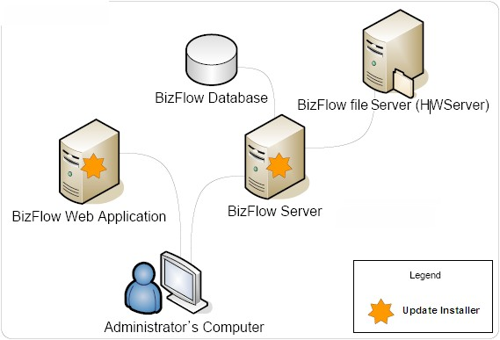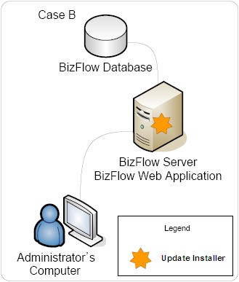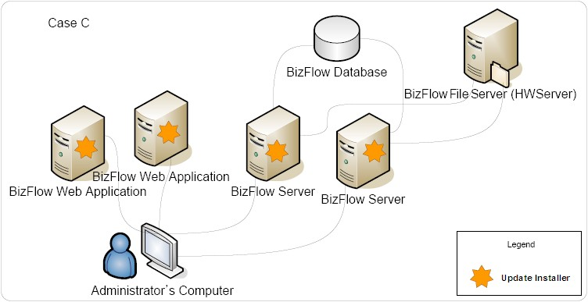

*BizFlow Update Installer – Server Configurations*

* For clustered web servers you should run the Update Installer on each server.
* For clustered BizFlow application servers the settings are tied together in the Update Installer for hwserver, database server and application server.

Because each app server points to the same shared hwserver file system and database, you should follow these steps:

1. On BizFlow app server #1, run the Update Installer and select *Change Settings* on the Welcome page.
2. Select components by checking the box *BizFlow Server and Database* as well as any other installed components (ERA, Form Service, etc.) to install those updates.
3. On BizFlow app server #2, run the Update Installer but do **not** select component *BizFlow Server and Database*. Do select the other installed components (ERA, Form Server, etc.).
4. Copy the file system from app server #1 to server #2.
5. On app server #2 make a copy of the following files:

◦~bizflowserver\bin\server.ini

◦~bizflowserver\bin\dat\license.lic

◦~bizflowserver\bin\dat\login.dat

◦~bizflowserver\bin\dat\serverinfo.dat

1. Copy from app server #1 to app server #2 the folders ~program files\bizflowserver\.
   1. (Windows only) Register two COM modules again: cd ~bizflowserver\bin

regsvr32 hwox.dll regsvr32 hwscript.dll

1. Replace files on app server #2 that were backed up in step 1 above.

## Installing BizFlow Update Installer in an AIX, HP-UX, Linux, or Solaris Environment

Before you can use the BizFlow Update Installer to install BizFlow updates, you must download and install the BizFlow Update Installer. Instructions vary depending on your operating system.

This section covers the following topics:

* Installing BizFlow Update Installer in a Windows Environment
* Installing BizFlow Update Installer in an AIX, HP-UX, Linux, or Solaris Environment
* Updating BizFlow Update Installer

### Downloading BizFlow Update Installer

Go to the BizFlow Product Download page at [http://download.bizflow.com/product/.](http://download.bizflow.com/product/) Use your login ID and password for support.bizflow.com to access this Web site. If you don’t have a login ID and password, contact BizFlow Customer Support.

Locate the BizFlow Update Installer directory. Download the distribution files listed below into the local directory of each target machine.

The target directory must have a minimum of 200MB of free disk space for installing BizFlow Update Installer. We recommend that you have an additional 2GB or more of free disk space for downloaded updates and temporary files.

Files to download:

* *os_type*/updateinstaller-os_type-*version*.zip
* *os_type*/install.sh
* *os_type*/unzip.*os_type*

Target directory:

* $HOME/bfpatches

Where: $HOME is the home directory of the BizFlow application owner who has read/write access to the BizFlow application installation directories.

### Installing BizFlow Update Installer

Make sure that you have at least the minimum required space on the target directory.

Run the following:

cd $HOME/bfpatches/ sh ./install.sh

The following is an example of the installation on Solaris:

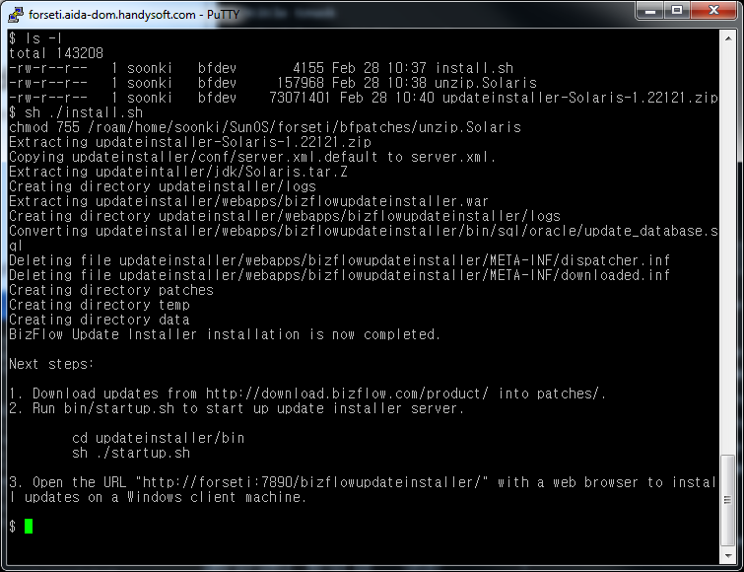

*Installing BizFlow Update Installer – Solaris*

BizFlow Update Installer uses the following dedicated ports: 7890, 7895 and 7899. If any of these ports is being used by another application, you can either stop the application temporarily, or you can change the port in the following configuration file:

$HOME/bfpatches/updateinstaller/conf/server.xml

If you change port 7890 in the configuration file, you must also change the URL for the Web browser to use the same port number. The other two ports are for internal use.

To check if any of these ports are already in use, run the following command:

netstat –an | grep "LISTENING" | grep ".7890" netstat –an | grep "LISTENING" | grep ".7895" netstat –an | grep "LISTENING" | grep ".7899"

### Starting the BizFlow Update Installer Server

To start the BizFlow Update Installer server, run the following:

cd $HOME/bfpatches/updateinstaller/bin/ sh ./startup.sh

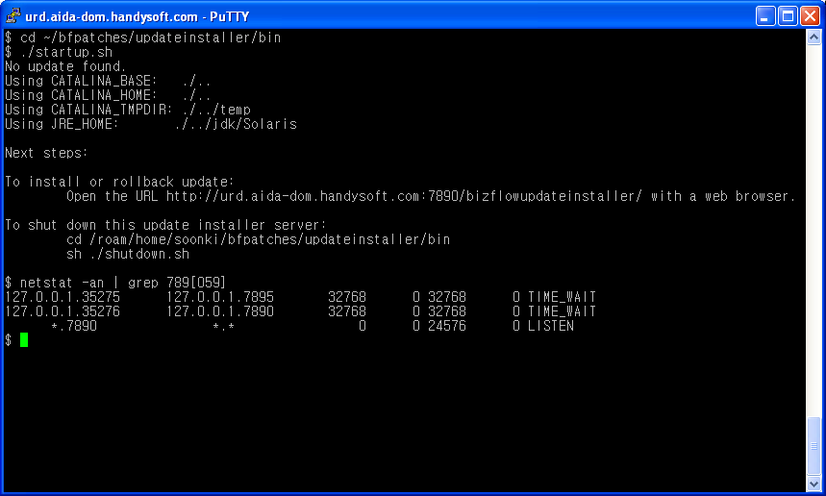

*Starting the BizFlow Update Installer – Unix*

### Stopping the BizFlow Update Installer Server

To stop the BizFlow Update Installer server, run the following:

cd $HOME/bfpatches/updateinstaller/bin/ sh ./shutdown.sh

### Starting the BizFlow Update Installer Client

Start up the BizFlow Update Installer server and then open the following URL on the same local machine or the administrator’s remote client machine:

http://*computername*:7890/bizflowupdateinstaller/

## Updating BizFlow Update Installer

You can update BizFlow Update Installer to a newer release in any of the following ways:

* Automatic Update
* Manual Update
* Offline Update

### Automatic Update

Every time the user logs in, the BizFlow Update Installer automatically checks whether a newer version is available. If so, the following message is displayed:

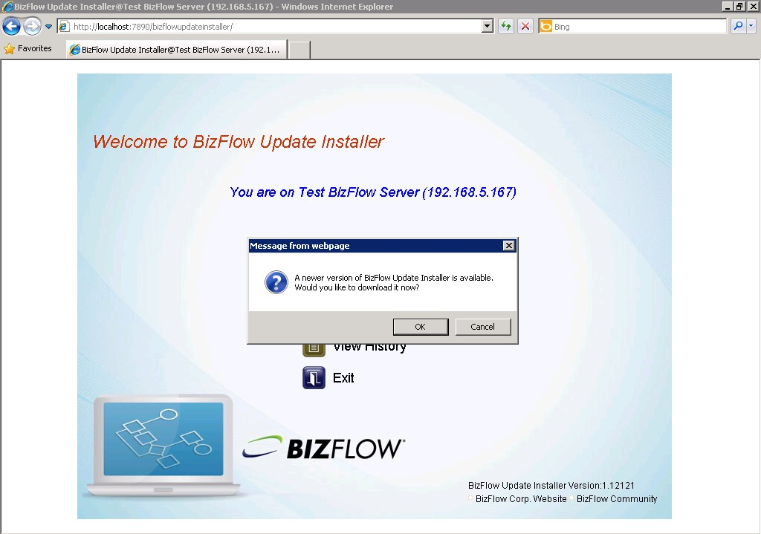

*Updating Your Version of BizFlow Update Installer*

Click *OK* to download the available update into the BizFlow Update Installer installation directory.

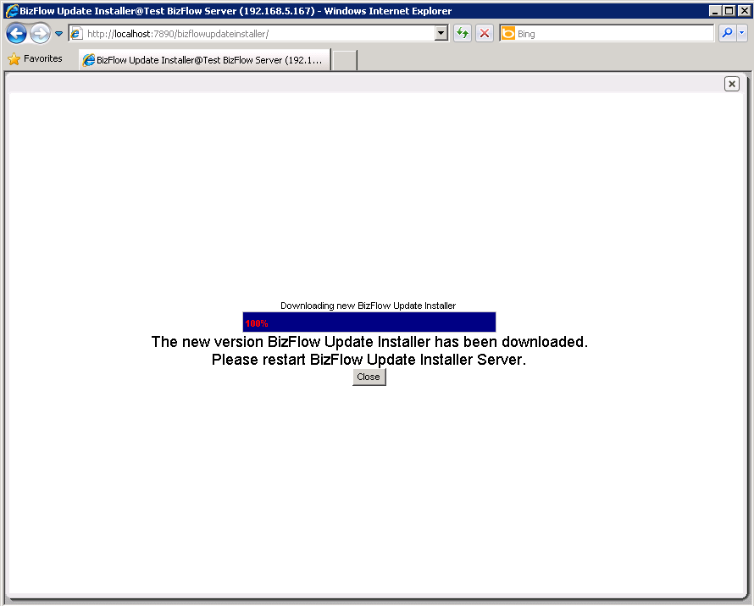

*Downloading an Updated Version of BizFlow Update Installer*

The updates will take effect at the next restart of the BizFlow Update Installer Server.

### Manual Update

Even though the BizFlow Update Installer has an auto-update feature, it only updates the web application.

To fully update the installer, including the install.bat and the embedded Tomcat portion, follow the instructions below.

1. Stop the BizFlow Update Installer server if it was running.
2. Go to the installation directory.
3. There may be zip files there from previous versions (updateinstaller-<OS_TYPE>-

<version>.zip). Remove all of them.

1. Go to the BizFlow Product Download page at <http://download.bizflow.com/product/> and download the following files:

* updateinstaller-<OS_TYPE>-<version>.zip
* install.bat (or install.sh)
* unzip.exe (or unzip.<OS_TYPE>)

1. Run install.bat (or install.sh) again.
2. Restart the BizFlow Update Installer.

Note: Re-running install.bat (or install.sh) will not change existing data. Any changes to the port configuration file (updateinstaller/conf/server.xml) or the installation data and history will be intact.

### Offline Update

The BizFlow Update Installer upgrades itself automatically as needed. However, to complete the upgrade internet access is required. The following instructions are only necessary if the BizFlow Update Installer does not have internet access.

1. From a computer where internet access is available, go to the BizFlow Product Download page at <http://download.bizflow.com/product/>and download the following files:

* updateinstaller-<OS_TYPE>-<version>.zip
* install.bat (or install.sh)
* unzip.exe (or unzip.<OS_TYPE>)

1. Place the above files on a portable storage medium, such as a USB Flash drive.
2. Login to the computer where the BizFlow Update Installer is installed.
3. Stop the BizFlow Update Installer server if it was running.
4. Go to the installation directory.
5. There may be zip files there from previous versions (updateinstaller-<OS_TYPE>-

<version>.zip). Remove all of them.

1. Migrate the files from the portable storage device to the installation directory.
2. Run install.bat (or install.sh).
3. Restart the BizFlow Update Installer.

Note: Re-running install.bat (or install.sh) will not change existing data. Any changes to the port configuration file (updateinstaller/conf/server.xml) or the installation data and history will be

## Using the BizFlow Update Installer

This section provides the information you need to know in order to login to and use the BizFlow Update Installer to install BizFlow updates or uninstall updates in order to roll back to a previous version of BizFlow.

The following topics are included in this chapter:

* + Setting Your BizFlow Update Installer Password
  + Welcome Page Overview
  + Changing Settings
  + Installing Updates
  + Uninstalling Installed Updates
  + Viewing Update History
  + Exiting BizFlow Update Installer

### Setting Your BizFlow Update Installer Password

You will be asked to set a password when you use the BizFlow Update Installer for the first time.

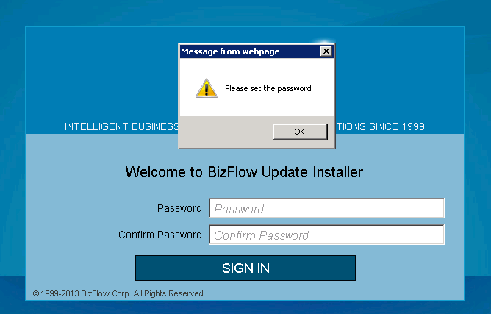

1. Click *OK*.
2. Enter a new password.
3. Type the password again to confirm.
4. Click *Sign In*.

### Welcome Page Overview

When you login to the BizFlow Update Installer you will see the following Welcome page:

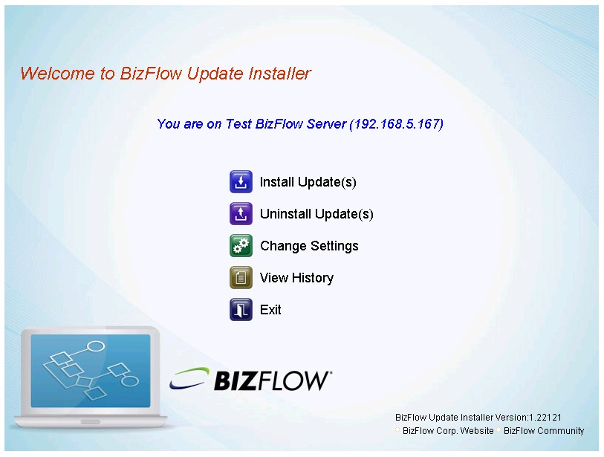

*BizFlow Update Installer Welcome Page – Menu Options*

The Welcome page provides the following menu options:

* + **Install Update(s)** – Install one or more updates at a time.
  + **Uninstall Update(s)** – Uninstall updates in order to roll back to a previous version of BizFlow.
  + **Change Settings** – Change your BizFlow Update Installer configuration.
  + **View History** – View and download update installation history.
  + **Exit** – Log out of BizFlow Update Installer.

### Changing Settings

You must configure your Update Installer after logging in to BizFlow Update Installer for

the first time or when the configuration information does not exist or changes on a system. The Change Settings menu option allows you to:

* + Set an alias for the server on which BizFlow Update Installer is running.
  + Configure the Update Installation History Database.
  + Select and configure the components that are installed on a server. When you install an update, only updates for components that you select will be installed.

To change BizFlow Update Installer settings:

1. Select *Change Settings* on the BizFlow Update Installer Welcome page.
2. You must set an alias for the server where BizFlow Update Installer is running. The alias is to help you distinguish the server upon which you are working. The alias is displayed in the title in your Web browser and on the Welcome page:

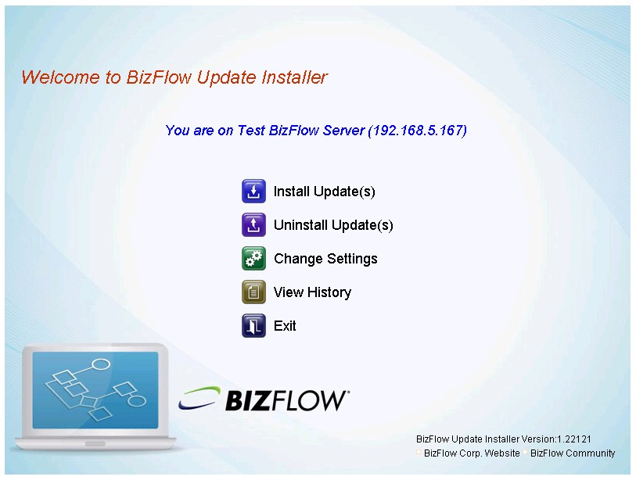

*BizFlow Update Installer Server Alias*

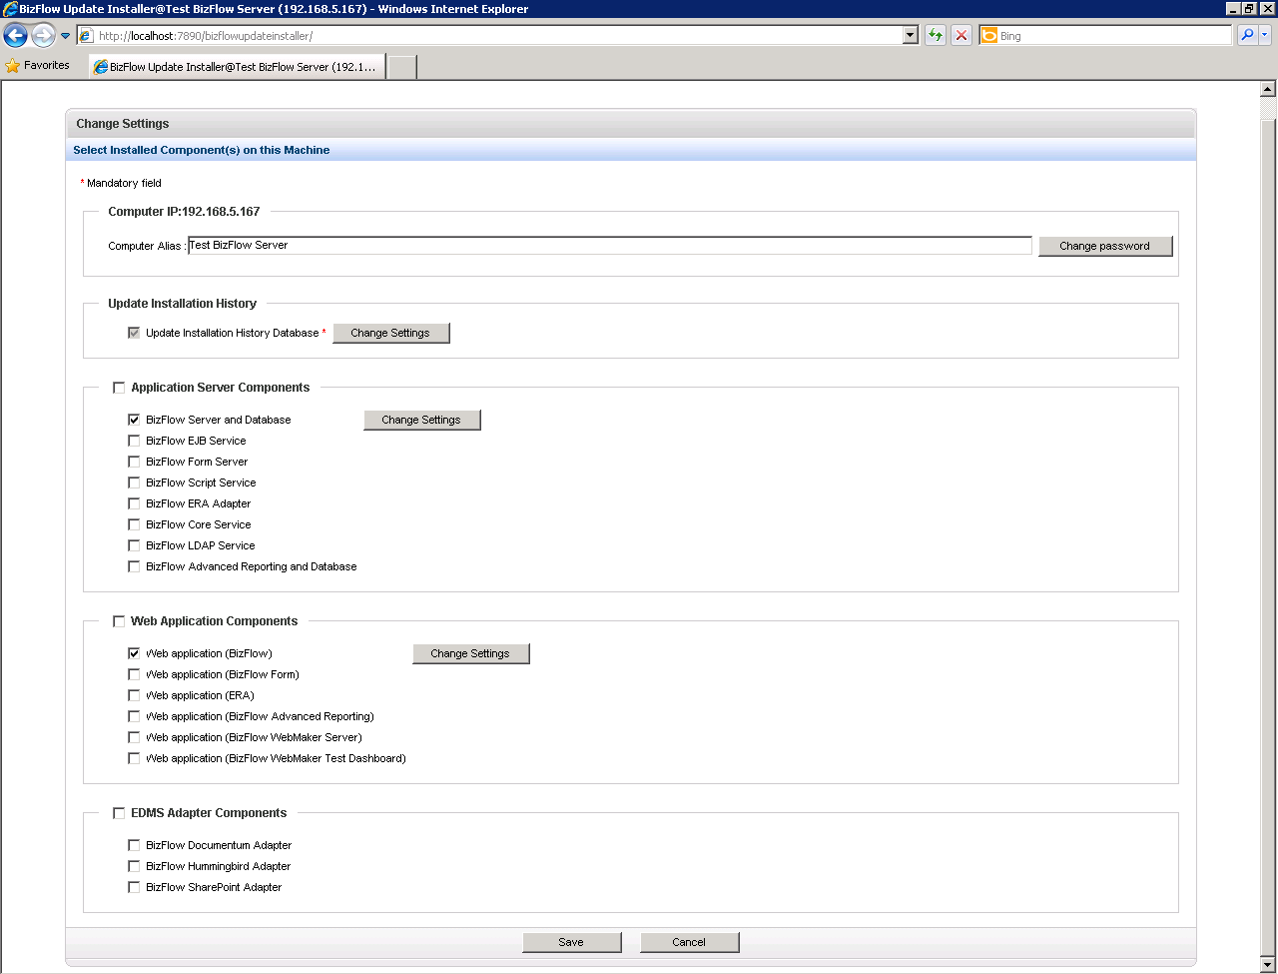

Specify an alias for the server.

Change the BizFlow Update Installer password.

Select and configure available components.

*Change Settings Page*

Note: The Update Installation History Database component is a mandatory component that you cannot turn off. This component keeps the update installation history. Therefore, you must configure this component with BizFlow database information.

For example, if a server has the BizFlow server, BizFlow database, and BizFlow Web application running on it, check *BizFlow Server and Database* in Application Server Components and *Web application (bizflow)* in Web Application Components.

After you select a component, a Change Settings button is displayed.

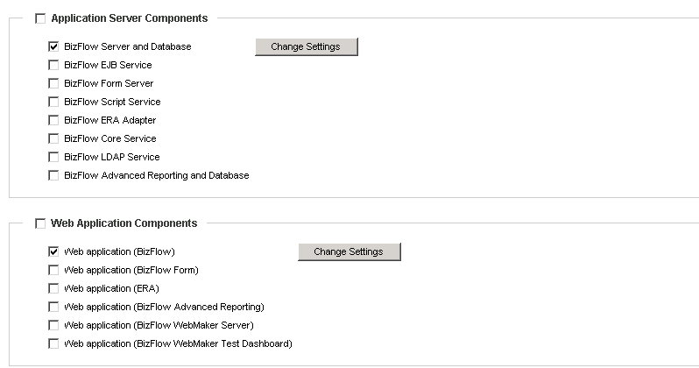

*Clicking Change Settings to Configure a Component*

1. Click *Change Settings* to configure that component. Each component has its own configuration, so you will see various configuration settings depending on the component. Some fields may be read-only where the value is automatically populated by another field. Mandatory fields are indicated by a red asterisk: *

Most of the required information in the component configuration area relates to paths where a component is installed on a server, or database information for BizFlow. If you do not know this information, ask your system administrator.

For example, if you click Change Settings for BizFlow Server and Database, you will see the following page:

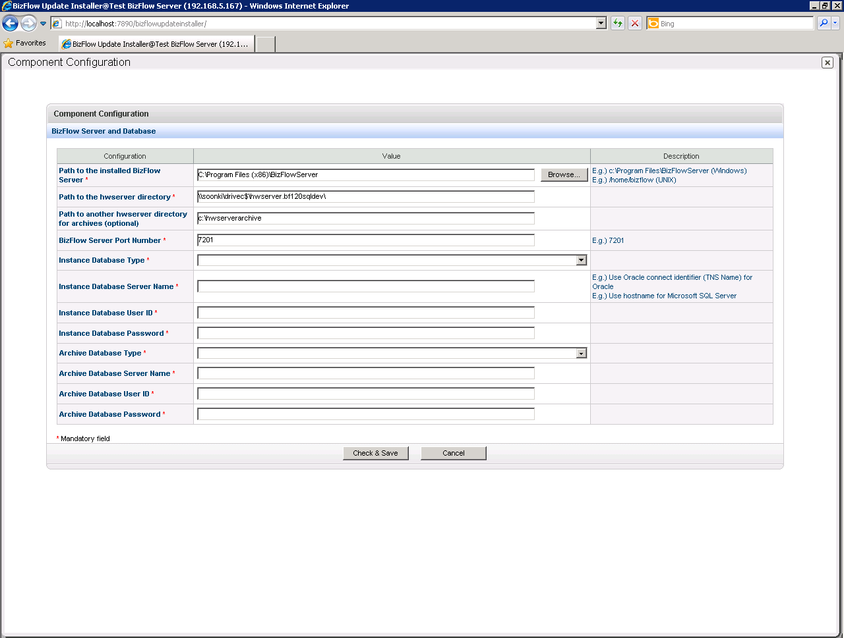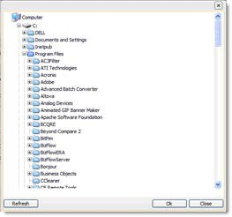

Mandatory Field

1. Next, you need to set the value for each field. If there is a field for a path, click *Browse…* at the end of the field to choose a path. You can also type a path directly into the field if you know it.

When you enter a path or select a path from the Path Browser, the BizFlow Update Installer validates the path; if it is invalid, an error message is displayed:

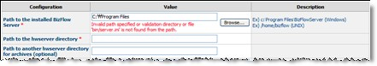

In this configuration, two fields are read-only fields: *Path to the hwserver directory* and *Path to another hwserver directory for archives (options)*; the value of these fields is populated when you enter a value in the *Path to the installed BizFlow Server*:

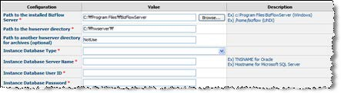

1. After all mandatory fields are set with values, click *Check & Save* to save your changes. BizFlow Update Installer validates the configuration. If there is a mandatory field for which you did not supply a value, an error message is displayed.

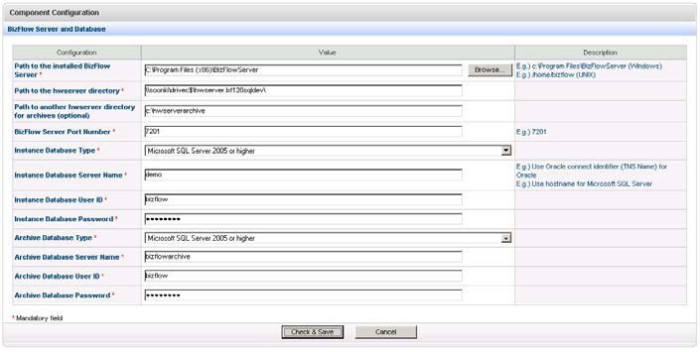

If a database connection was added or changed, BizFlow Update Installer will try to connect to the database. If there is an error connecting to the database, BizFlow Update Installer will display an error message:

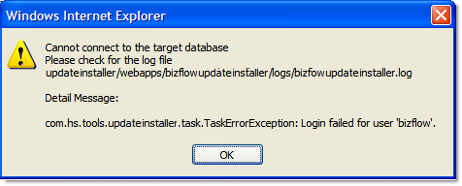

1. A configuration cannot be saved until all validation processes succeed. You must click *Save* after resolving validation and connection issues:

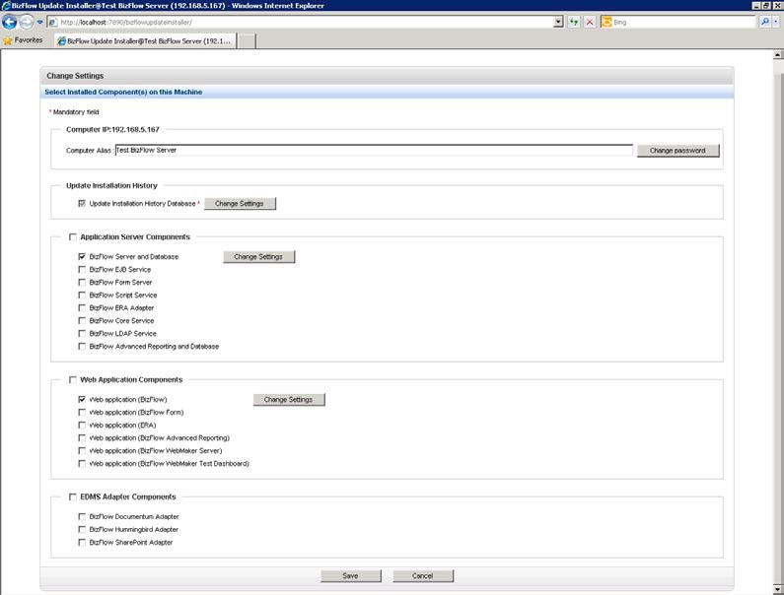

You must click *Save* after resolving validation and connection issues to save your changes.

1. The Update Installation History Database is used to keep the update installation history on a database.

This database is usually the same database that is used by the BizFlow Server.

If it is the same, you must configure the database information for BizFlow in two places: BizFlow Server and Database and Update Installation History Database. This is necessary because BizFlow Server and Database may not be selected on a server, so BizFlow Update Installer cannot access the BizFlow database information.

Click Change Settings next to Update Installation History Database. The following page is displayed:

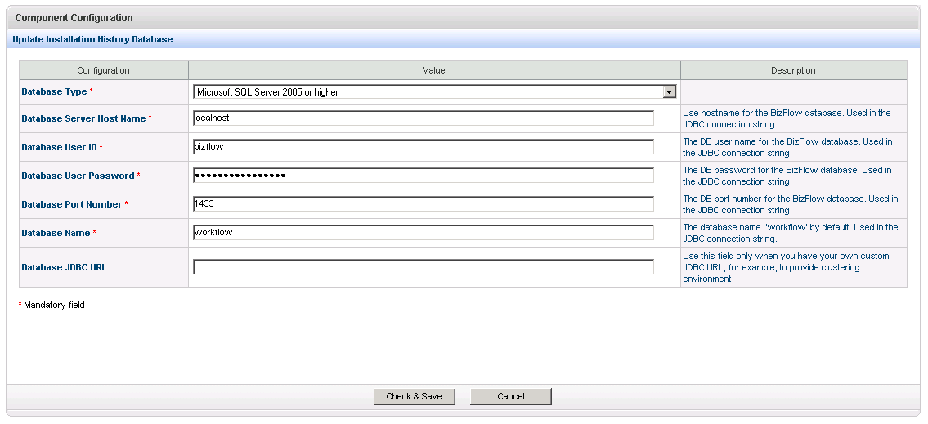

1. Enter the correct values in all mandatory fields.
2. Click *Check & Save* to verify your entries. If you get an error message, update the values as needed and click *Check & Save* again.
3. Click *Save* to save your changes when all entries are correct.

### Installing Updates

Retrieve the zip file or files for your update and all of its dependent updates (if required) and place the zip or zips in a folder called patches. For example: c:\bfpatches\patches on Windows or /home/bizflow/bfpatches/patches on UNIX.

* 1. Select *Install Update(s)* on the Welcome page menu.
  2. If a new update zip file was added to the patches directory, the update zip file is extracted automatically.

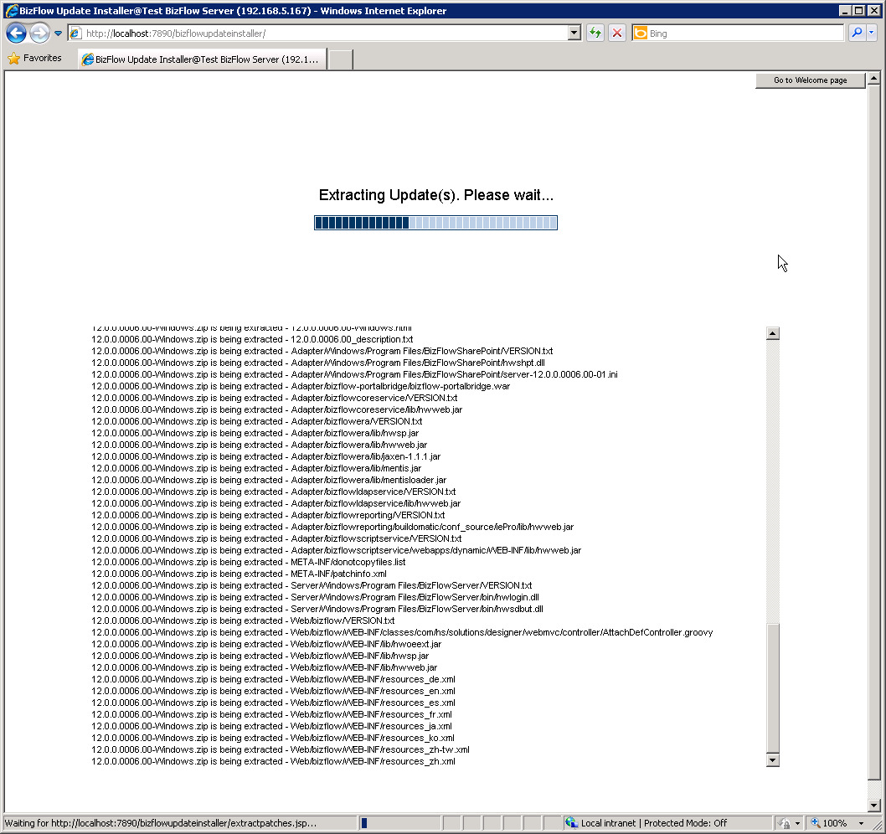

*Extracting Updates from the Update Zip Files*

* 1. Once all update zip files have extracted successfully, the following page appears where you select the update(s) you want to install:

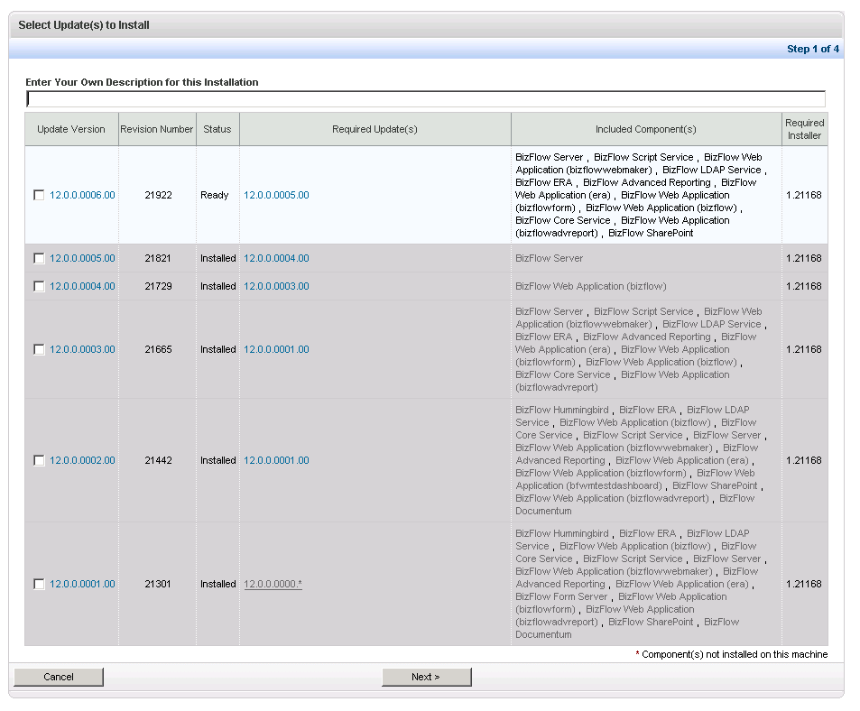

*Selecting Updates to Install*

Notes:

* + A red asterisk * indicates components that are included in an update but are not installed on the machine.
  + Status has one of the following values:
    - **Ready**: An update has not been installed.
    - **Installed**: An update has already been installed.
    - **Need more update(s)**: More than one dependent update does not exist in the patches folder, so you need to get the missing updates.
  1. Enter a description for this update installation in the description field.
  2. Check the update or updates that you want to install.
  3. Click *Next* when you are done selecting updates. BizFlow Update Installer displays a page that allows you to confirm or change your BizFlow Update Installer settings:

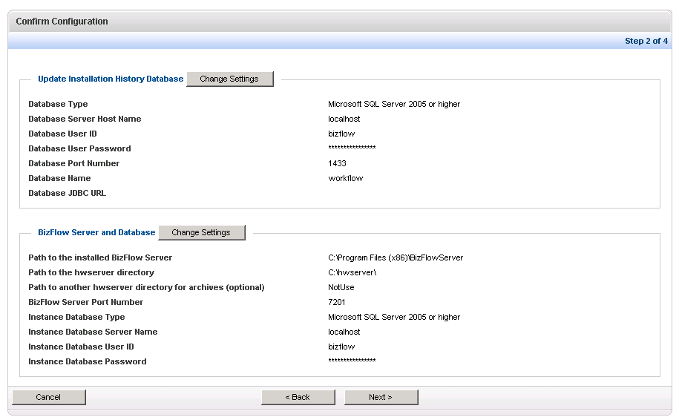

*Confirming the BizFlow Update Installer Configuration*

* 1. Review the information to make sure it is correct. If not, click *Change Settings* to change the settings.
  2. Click *Next*.

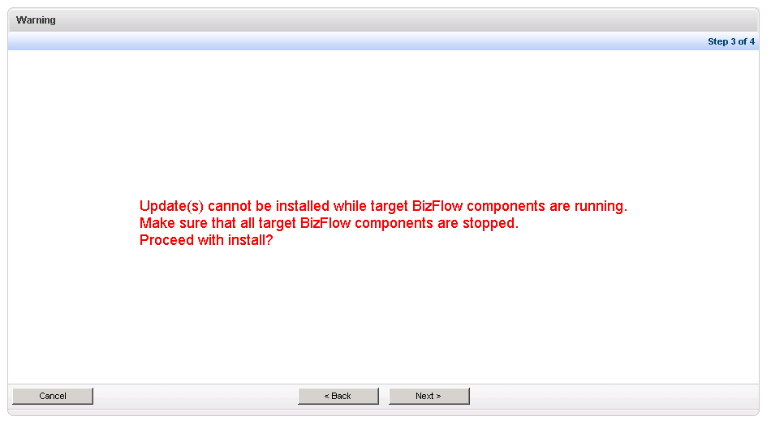

*Are all BizFlow components stopped?*

* 1. Updates cannot be installed while target BizFlow components are running.

Make sure that all target BizFlow components are stopped. Click Next when you are ready to proceed with the installation.

* 1. Click *OK* to start installing the update(s). Update Installer installs the selected Updates and you can watch the status of the installation while it is in progress. The status is automatically updated, but you can manually refresh the page.

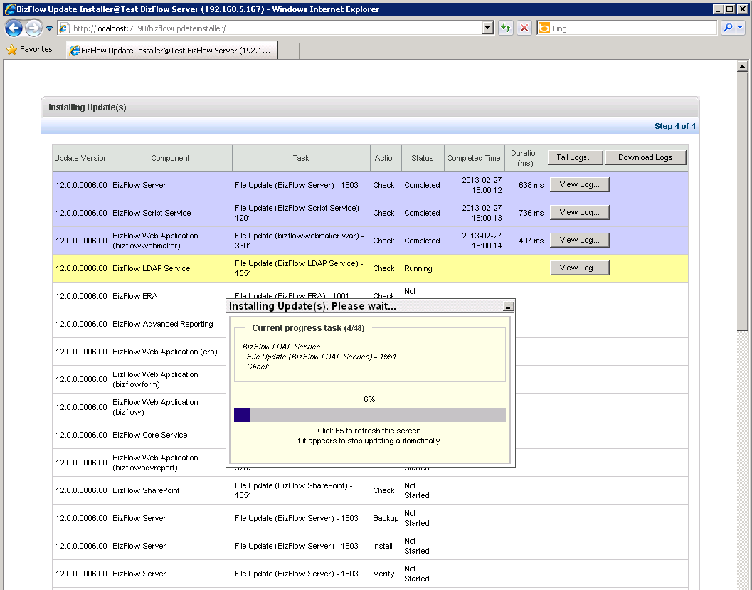

*Update Installation in Progress*

Notes:

* + - The installation **will** continue even if you close the Web browser. You can return to this page when you login to BizFlow Update Installer again.
    - Status has one of the following values:
      * **Not Started**: The installation task has not started.
      * **Running**: The installation task is in progress.
      * **Completed**: The installation task has finished.

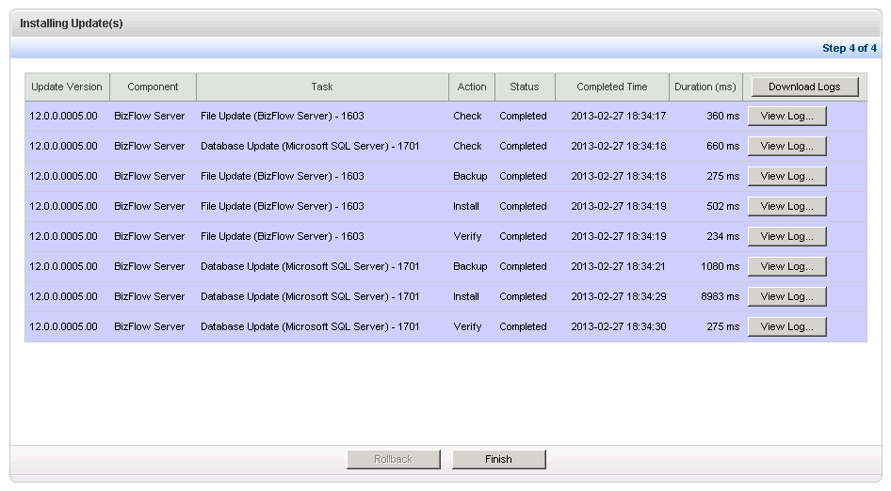

Click *Finish* if the update installations completed successfully.

Click *View Log* to view the log file.

*Installation Completed Successfully*

* 1. If the installation finishes without an error, the Finish button appears. Click *Finish* to complete the installation. If the installation does not finish correctly, you will see Error in the Status column:

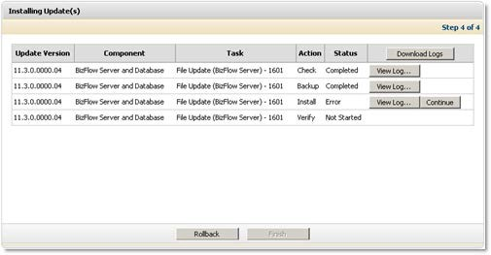

Click *Rollback* to roll back the update installation.

Patch installation stopped due to error.

*Installation Failed*

When an error occurs, BizFlow Update Installer stops installing the current update being installed. The current update and subsequent updates will not be installed until the error is resolved. You can do one of the following:

* + - Fix the error and then click *Continue* to retry the installation of the individual update.
    - Roll it back and then start installation of all the updates again.
  1. Click *View Log* to view the installation log to find out why the error occurred.

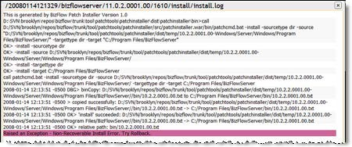

*Update Installation Error Log*

* 1. Resolve the error, and then click *Continue* to continue with the installation.



**Note:**

If you cannot fix the error or an error recurs, roll it back and contact Customer Support.

## Uninstalling Installed Updates

To roll back installed updates:

1. Select *Uninstall Update(s)* on the Welcome page menu.
2. The following page is displayed, showing installed **transactions**:

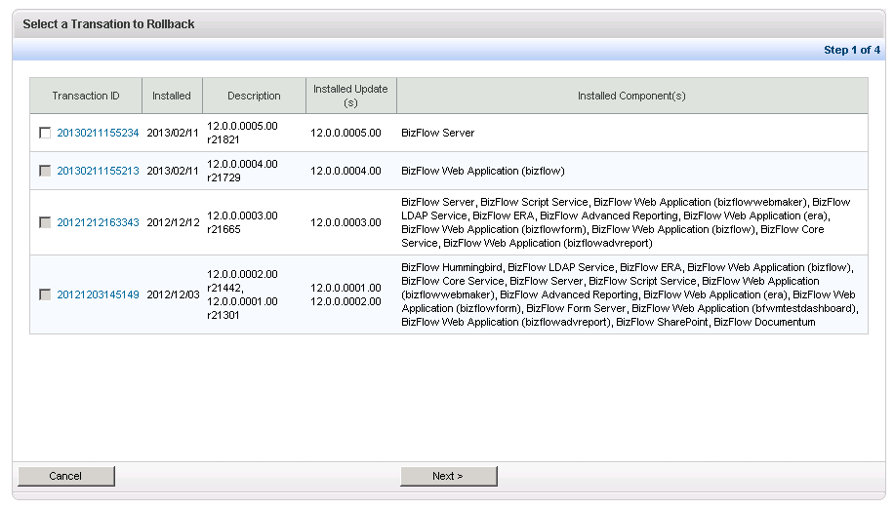

*Selecting a Transaction to Roll Back*

Notes:

* + A BizFlow Update Installer **transaction** is an installation unit made up of one or more updates that are installed together. This allows you to roll back a group of updates that were installed together.

1. Click the Transaction ID to see additional details about the transaction installation.

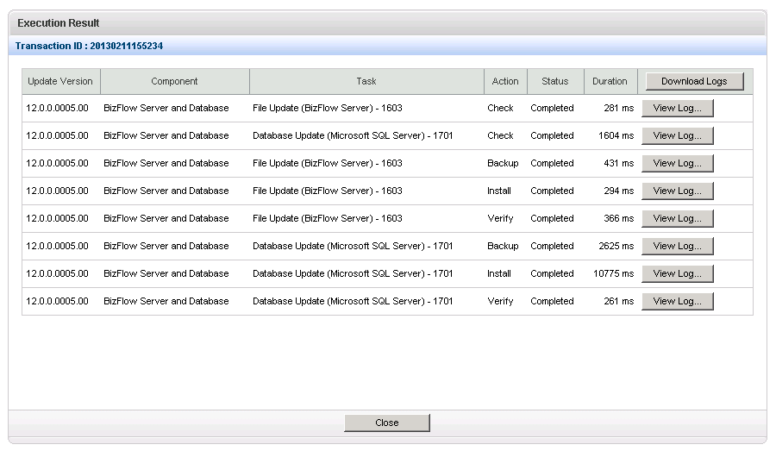

Click *Close* to close the window and return to the Select a Transaction to Rollback page.

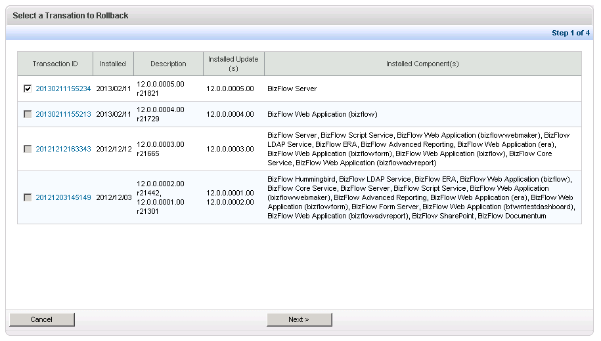

*Selecting the Last Transaction*

1. Select the last transaction (at the top of the list) and click *Next*. BizFlow Update Installer displays a page that allows you to confirm or change your BizFlow Update Installer settings.

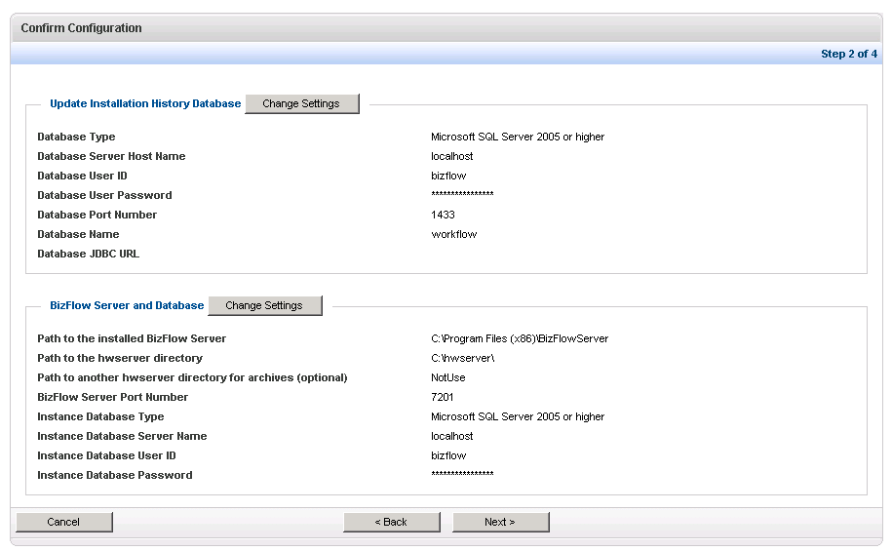

*Confirming the BizFlow Update Installer Configuration*

1. Review the information to make sure it is correct. If not, click *Change Settings* to change the settings.
2. Click *Next*.

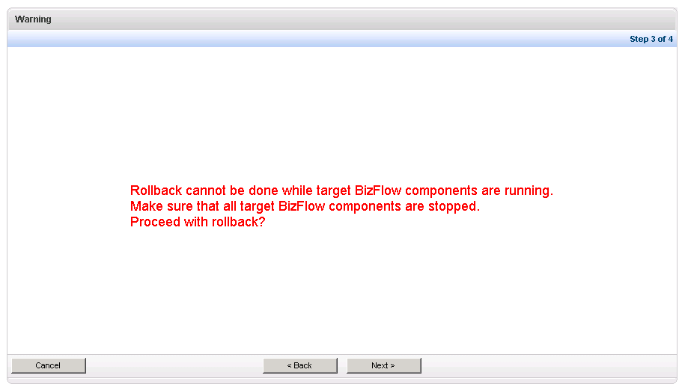

*Are all BizFlow components stopped?*

1. Rollback cannot be done while target BizFlow components are running.

Make sure that all target BizFlow components are stopped. Click Next when you are ready to proceed with the rollback.

1. BizFlow Update Installer rolls back the selected Updates and you can watch the status of it while it is in progress. The status is automatically updated, but you can manually refresh the page.

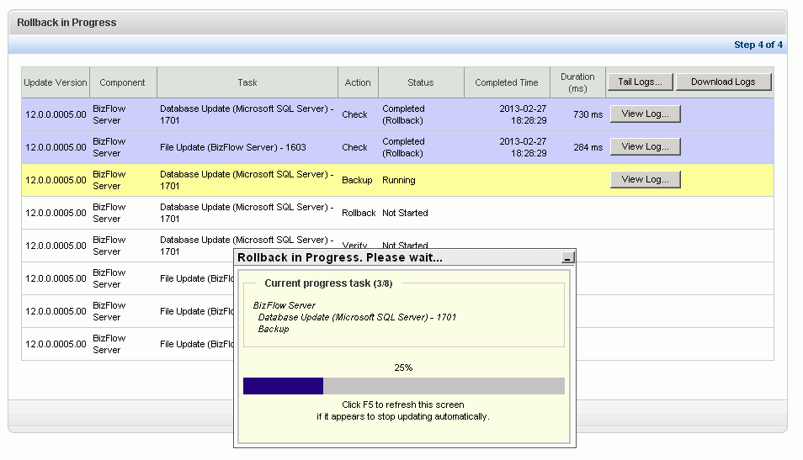

*Rollback in Progress*

Notes:

* + The rollback **will** continue even if you close the Web browser. You can return to this page when you login to BizFlow Update Installer again.
  + Status has one of the following values:
    - **Not Started**: The rollback task has not started.
    - **Running**: The rollback task is in progress.
    - **Completed**: The rollback task has finished.

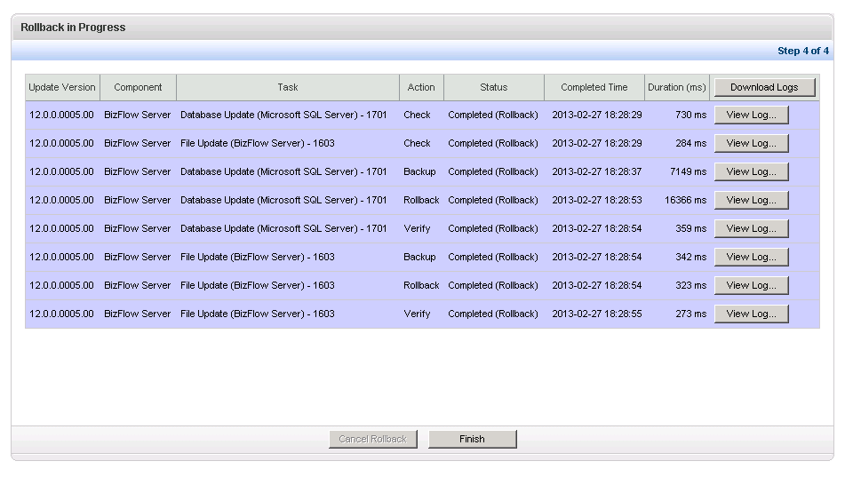

1. If the rollback finishes without an error, the Finish button appears. Click *Finish* to complete the rollback. If the rollback does not finish correctly, you will see Error in the Status column.

**Note:**

If you cannot fix the error or an error recurs, contact Customer Support.

## Viewing Update History

To view a history of the Updates you have installed:

1. Select *View History* from the Welcome page menu. The View History page is displayed:

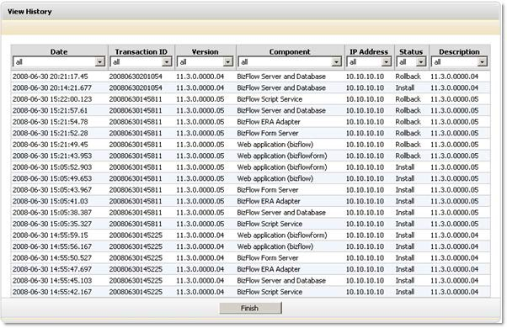

1. Click a Transaction ID to see results on the execution of a specific transaction:

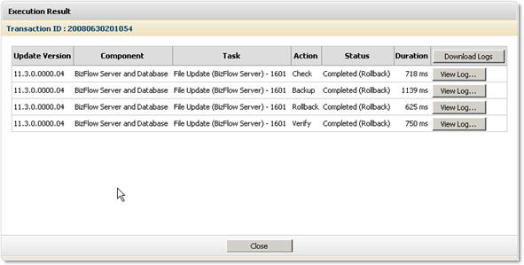

From the Execution Result page, you can:

* + Click *Download Logs* to download a zip file that contains all of the logs for all transactions.
  + Click *View Log* to view the log for a single transaction.
  + Click *Close* to close the window.

## Exiting BizFlow Update Installer

Stop the BizFlow Update Installer after you have performed the desired maintenance. To exit the BizFlow Update Installer, select *Exit* on the Welcome page menu.

About Deloitte

Deloitte provides audit, tax, consulting, and financial advisory services to public and private clients spanning multiple industries. With a globally connected network of member firms in 140 countries, Deloitte brings world-class capabilities and deep local expertise to help clients succeed wherever they operate. Deloitte's 165,000 professionals are committed to becoming the standard of excellence.

Deloitte's professionals are unified by a collaborative culture that fosters integrity, outstanding value to markets and clients, commitment to each other, and strength from cultural diversity. They enjoy an environment of continuous learning, challenging experiences, and enriching career opportunities. Deloitte's professionals are dedicated to strengthening corporate responsibility, building public trust, and making a positive impact in their communities.

Deloitte refers to one or more of Deloitte Touche Tohmatsu, a Swiss Verein, and its network of member firms, each of which is a legally separate and independent entity. Please see www.deloitte.com/about for a detailed description of the legal structure of Deloitte Touche Tohmatsu and its member firms. Please see <http://www.deloitte.com/us/about> for a detailed description of the legal structure of Deloitte LLP and its subsidiaries.

Internal Usage Statement

This publication is for internal distribution and use only among personnel of Deloitte Touche Tohmatsu, its member firms, and its and their affiliates. Deloitte Touche Tohmatsu, its member firms, and its and their affiliates shall not be responsible for any loss whatsoever sustained by any person who relies on this publication.

Copyright © 2012 Deloitte Development LLC. All rights reserved.

Member of Deloitte Touche Tohmatsu